

PROJECT REPORT
On
An Intelligent Framework for Smart Classroom Allocation and
Timetable Scheduling in Higher Education Institutions
Submitted to
LOVELY PROFESSIONAL UNIVERSITY
In partial fulfilment of the requirements for the award of degree of
Master of Computer Applications
Submitted By Supervised By
Rahul Jangu 12400252 Dr. Kanika Sharma
Abhishek Kashid 12417008 Associate Professor
Gresi Mittal 12412563
Aman Kumar 12405301
Rishav Raj Pandey 12416225

LOVELY FACULTY OF TECHNOLOGY & SCIENCES
LOVELY PROFESSIONAL UNIVERSITY
PUNJAB
[MAY 2025]

To whom so ever it may concern
We, Rahul Jangu (12400252), Abhishek Kashid (12417008), Gresi Mittal (12412563), Aman Kumar (12405301) and Rishav Raj Pandey (12416225) hereby declare that the work done by us on “An Intelligent Framework for Smart Classroom Allocation and Timetable Scheduling in Higher Education Institutions” under “ Dr. Kanika Sharma (UID: 20452)” from January 2025 to May 2025 at Lovely professional University, Phagwara, Punjab, is a record of original work for the partial fulfilment of the requirements for the award of the degree Master of Computer Applications. The results embodied in this report have not been submitted to any other subject or university.

Submitted By
Rahul Jangu Abhishek Kashid Gresi Mittal Aman Kumar Rishav Raj Pandey
12400252 12417008 12412563 12405301 12416225

CERTIFICATE

This is to certify that the project report titled “An Intelligent Framework for Smart Classroom Allocation and Timetable Scheduling in Higher Education Institutions” is being submitted by Rahul Jangu (12400252), Abhishek Kashid (12417008), Gresi Mittal (12412563), Aman Kumar (12405301) and Rishav Raj Pandey (12416225) in MCA 4th semester is a record of Bonafide work carried out by them. The results embodied in this report have not been submitted to any other University for the award of any degree.

Signature and Name of the Supervisor: Dr. Kanika Sharma (UID : 20452)
Designation: Associate Prof, SCA
Date:

Signature of AO:
Date:

ACKNOWLEDGEMENT

For all the efforts behind the paperwork & project, we first & for most would like to express our sincere appreciation to Dr. Kanika Sharma (UID:20452), School of Computer Applications for their extended help & suggestions at every stage of this project work. It is with a great sense of gratitude that we acknowledge the support, time to time suggestions and highly indebted to our guide. Finally, we pay sincere thanks to all those who indirectly and directly helped us towards the successful completion of the real time project “An Intelligent Framework for Smart Classroom Allocation and Timetable Scheduling in Higher Education Institutions” for End Term Practical.

With due regards:
Rahul Jangu 12400252
Abhishek Kashid 12417008
Gresi Mittal 12412563
Aman Kumar 12405301
Rishav Raj Pandey 12416225

ABSTRACT

Managing resources in universities is still a major challenge, especially when it comes to timetable creation and classroom allocation. In many cases, manual work leads to errors, uneven faculty workload, and poor use of available rooms. Because of this, institutions often face scheduling conflicts and inefficiencies. To overcome these issues, our project introduces an Intelligent Framework that uses automated techniques and cloud-based support to improve how resources are handled and to identify possible scheduling problems in advance.
In this project, we designed a software-based solution that helps in organizing academic activities in a better way. The system checks classroom availability, faculty expertise, and student batch requirements before generating a timetable. The main goal was to build a centralized scheduling engine that can assign time slots efficiently. While generating the schedule, the system considers important factors such as subject type, credits, and whether the class requires a theory room or a lab.
We also focused on building a structured system architecture and evaluating how it performs in real scenarios. The solution includes features like automated scheduling logic, bulk data handling for student and faculty records, and real-time notifications for users. Our web-based application provides an interactive interface where timetables can be managed easily, batches can be divided into groups (G1/G2), and both students and teachers can track their schedules through dashboards.
Overall, the system helps in reducing scheduling conflicts and improves coordination between different departments. By using this approach, institutions can manage their academic operations more smoothly and ensure better utilization of available resources.

PERFORMA

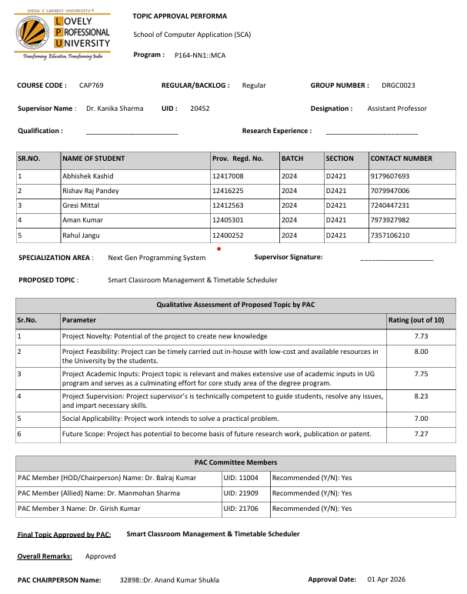

Publication Details

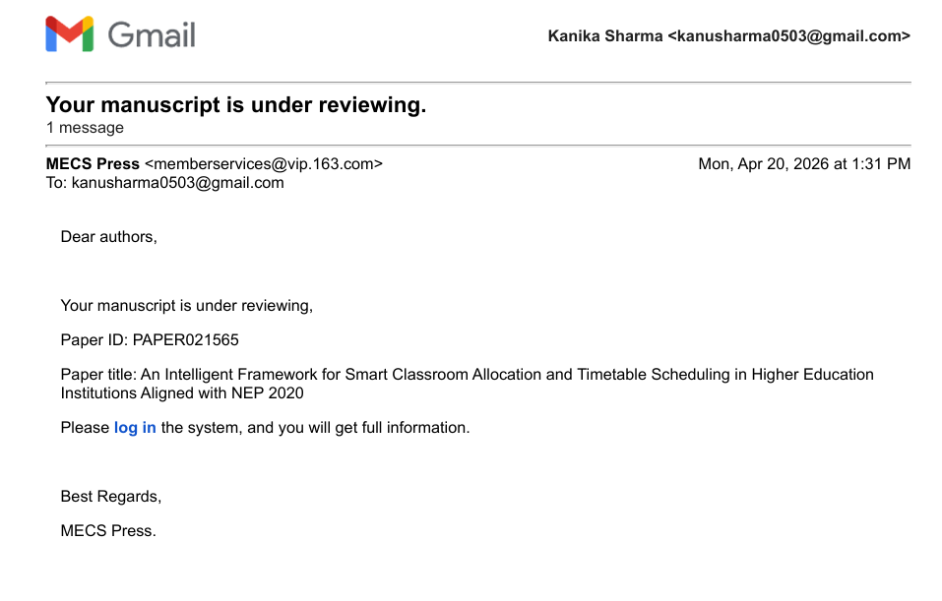

Plagiarism Report

Table of content
S. No | Title | Page No
1 | Chapter 1  Introduction | 10
2 | 1.1 Motivation for the work | 10
3 | 1.2 Problem Statement | 11
4 | Chapter 2  Literature review | 12
5 | Chapter 3  Implementation of project  3.1 Objectives | 14
6 | 3.2 Methodology | 16
7 | 3.3 Existing System | 18
8 | 3.4 Proposed System | 19
9 | 3.5 Algorithm | 21
10 | 3.6 Experimental Work | 23
11 | 3.7 Sample Code | 25
12 | 3.8 List of Figures | 37
13 | Chapter 4  Result and Discussion | 46
14 | Chapter 5  Conclusion and Future Scope | 48
15 | Appendix | 49
16 | References | 51

Chapter 1
Introduction

It should be mentioned that the problem of improper timetables and insufficient allocation of resources is still an ongoing challenge faced by Indian educational establishments. The academic schedule of numerous universities was heavily affected during the academic period 2023-2024 due to poor planning and lack of efficient allocation of classroom spaces. Due to the fact that the number of students constantly increases, it becomes harder to allocate classrooms in accordance with the traditional methods. The poor distribution of workload across faculties, the lack of infrastructure, and departmental inefficiencies may cause chaos within the academic environment.
Therefore, in order to solve these kinds of challenges, we introduced our framework, called 'Intelligent Framework for Smart Classroom Allocation.' Apart from solving the issues related to effective timetabling, the system significantly helps in improving the level of efficiency in a university setting. Hence, our system saves a lot of unnecessary manual labor, thus decreasing the possibility of human errors. It also makes the workload distribution process much easier while helping allocate classrooms in an appropriate manner. According to NEP 2020 of the Indian government, digitization is crucial in developing education..
Through the use of technology such as AI, the system will be able to analyze the information and make better decisions when scheduling. This technology is beneficial since it enables the administration to optimize resource allocation and give effective control to the HOD for monitoring educational activities within the institution. Moreover, it makes it easier to coordinate the operations among different departments through the dissemination of information at real time. Through data analysis, problems can be identified in advance, which results in corrective action.

1.1 MOTIVATION FOR THE WORK
Major universities and specialized educational facilities always face multiple issues in aligning their physical facilities with the human resources. Ineffective academic schedule causes a chain reaction effect impacting the quality of teaching, faculty attitude, and operational efficiency of the institution. However, the academic world especially feels the negative consequences of ineffective resource utilization and decline in engagement time of students and teachers.
The principal source of motivation behind this study stems from the complex nature of manual resource management. It is impossible to create an interference-free schedule in light of numerous factors involved such as overlapping faculty expertise, different room configurations, fluctuating number of students, and specific course prerequisites. In today's digital age, there is a critical demand for an Intelligent Framework to cope with those issues.
The use of neural algorithms for managing schedule combined with a centralized dashboard and classroom scanners backed by powerful cloud infrastructure opens up new possibilities of handling resource conflicts. Thus, such platform becomes a "Neural Hub" sending automatic notifications about class schedules and other details of interest to users' mobile phones.
This particular project will revolve around creating a user-oriented software application designed to help solve logistic problems at every stage, starting from each individual batch to all faculty members on a global level. The ability to understand how the workload is distributed amongst each educator through the software terminal will allow for a more concentrated and stable educational system. In summary, the main objective will be to turn the process of academic logistics from something very complicated and full of errors into an effortless automated process.

1.2 PROBLEM STATEMENT
One of the recurring challenges facing university departments and other higher learning organizations has been that of managing scheduling conflicts and infrastructure contention. There have continued to be difficulties in formulating a proper academic road map ahead of the start of an academic semester due to logistical issues. Some of these include the non-linearity of classroom space, imbalance in faculty allocation, as well as the lack of decision support tools based on real-time data. As a result of all these logistical issues, productivity in institutions is negatively affected, with the academic community suffering the repercussions of manual scheduling. Even though attempts have been made in order to incorporate conflict resolution tools in the scheduling process, there is a critical need for systems that offer comprehensive decision support ahead of the planning stage, which is currently missing. Another important shortfall is that the majority of conflict resolutions are reactive, occurring after the identification of resource clashes or overlapping departmental functions, rather than proactive. Moreover, current educational institutions are lacking the necessary resource allocation tools for mapping available classroom space against high-level factors.
The present scenario demands the design of an intelligent technological ecosystem capable of identifying resource constraints and executing the master timetable flawlessly. The foremost issue that needs to be addressed is designing software that demonstrates efficient algorithms but does not sacrifice ease of use when viewed from a user-centric perspective. The proposed study is geared towards filling this vacuum by designing an Intelligent Framework capable of optimizing the resource distribution process using neural monitoring tools and preventing any academic delays.
CHAPTER 2
LITERATURE REVIEW

A number of academics have sought to explore and find solutions to the different causes of inefficiencies in academic management practices. The findings obtained show that there are several logistical issues that affect the breakdown of the conventional scheduling process. Universities have resource conflict due to the complex structures, unpredictable faculty timetables, and absence of integrated information among the academic departments.
There have been many attempts made to handle the complexity of academic scheduling. However, traditional methods of manual scheduling that utilize spreadsheet management, department meetings, and paper edits have shown very minimal effectiveness when employed by universities with large student enrollments. Nonetheless, manual methods are reactive strategies that are employed only after the conflict occurs between the resources. In addition, there is increasing interest shown by researchers in using artificial intelligence technologies to provide proactive support in the management of academic scheduling processes. Current research has shown that technological tools such as Automated Scheduling Engine (ASE) are critical in reducing administration burden. The use of ASE allows the analysis of various institutional elements including the faculty load, classroom structure, knowledge map, and student cohort. After analysis, these elements could form a basis for effective academic plans.
Moreover, new technological innovations such as Artificial Intelligence (AI) and Machine Learning (ML) have been utilized for forecasting future scheduling problems accurately. Mobile technology and ERP systems are other means that contribute to improved communication between the administration and faculty members. This is a problem that is highly challenging for all sections of higher learning institutions. Therefore, there is need for digital solutions as provided by technological developments. Thanks to these developments in technology, most firms are implementing digital ecosystems whereby the learners, educators, and management are all integrated into one platform. This digital ecosystem acts as a central hub for alerts sent to the HODs concerning resource misallocation..
The provision of holistic institutional development through such systems will allow universities to make timely adjustments regarding their operations. Moreover, adaptive scheduling systems that can automatically adjust the schedule according to faculty leave trends and room maintenance cycles provide a personal touch when it comes to managing institutions. Such systems assist the management teams in displaying information about their classes in such a way as to optimize occupancy levels as well as optimizing the pedagogic process of instruction. Apart from assisting administrators, virtual availability scanners also ensure that there are no gaps in logistics that may be overlooked. In terms of management beyond institutional boundaries, it is apparent that cloud scheduling apps as well as remote monitoring capabilities are facilitating access to schedules at all times, even in decentralized learning environments. Moreover, institutional leadership as well as government agencies are also assisting in the process by endorsing digital literacy and IT infrastructures in higher education institutions.

CHAPTER 3
IMPLEMENTATION OF PROJECT

3.1 OBJECTIVES
1. Primary Goal and System Governance:
The main objective of this initiative is to eliminate academic operational inefficiencies and resource clashing through an intelligent scheduling framework. To achieve this, a comprehensive software solution (LPU Neural Hub) has been developed where the administration manages the entire infrastructure, including rooms, departments, faculty, and student batches. The system follows a strict administrative hierarchy where the addition or removal of academic units is restricted to the Admin. The framework features three distinct neural interfaces:
- Student Interface: Allows learners to access their personalized "Active Matrix" (timetable), track their attendance, and access academic resources.
- Teacher Interface: Provides faculty with workload analytics, room allocation status, and access to the student database of their respective departments.
- HOD Interface (Departmental Optimization Hub): The departmental brain of the system. HODs have access to the Neural Scheduling Engine to generate optimized timetables, use the Room Availability Scanner to locate empty nodes, and monitor department-wide analytics and faculty workloads.
- Admin Interface: A global command center with unrestricted access to system-wide data, including infrastructure registry and financial aid oversight.
2.Identification of Scheduling Anomaly and Operational Risk:
The system employs a longitudinal tracking mechanism to identify "Friction Points" in the academic journey based on three specific analytical criteria:
- Attendance Stability: Monitoring persistent falls in student classroom participation, which often indicates scheduling fatigue.
- Scholastic Performance Trends: Identifying sharp declines in grades, suggesting that the current timetable/curriculum delivery is not aligned with student needs.
- Engagement Dynamics: Tracking a degrade in student behavior or interaction within the recent academic cycle, signaling a potential withdrawal from the system.
If a downward trend in any of these parameters persists continuously for three academic cycles (years), the system automatically triggers a high-priority "Neural Alert." Both the faculty and admin will receive a notification, and a "Red Line Indicator" will be marked on the profile to initiate immediate administrative intervention.

3. Fectors Leading to Academic Abandonment:
The research identifies four key elements that lead to educational discontinuation, which this framework aims to resolve:
- Insufficient pedagogical support from faculty or the institutional system.
- Socioeconomic/Financial hardships stopping students from progressing in their tenure.
- Lack of personalized mentoring or parental involvement in the academic roadmap.
- Poor student engagement due to rigid and unoptimized scheduling.

4. Core Functional Modules for System Optimization:
To overcome these challenges, five specialized modules have been incorporated into the software architecture:
- Early Warning System (EWS): A predictive engine that analyzes historical data to forecast which students or resources are "At Risk." It proactively informs the HOD and Admin to take corrective scheduling measures.
- Community Hub Platform: An interactive digital ecosystem featuring virtual classrooms, an online book library, and virtual tutoring nodes. This reduces academic disinterest by providing flexible learning alternatives when physical nodes are congested.
- Adaptive Learning Matrix: A web platform where students receive curated reading materials and domain-specific quizzes. It includes real-time progress tracking to ensure the timetable remains effective for the student's pace.
- Automated Financial Aid Management: Addressing the critical economic barrier. Students with a minimum of 75% attendance and a CGPA of 7.5 in recent semesters can apply for financial assistance. The system automates the workflow by generating a verified PDF document for bank submission. Once approved by the Admin, funds are reimbursed directly to the college pool, enabling a seamless educational loan process without external manual hurdles.
- Student Support and Engagement Hub: A holistic module providing counseling resources and motivational content. It ensures students maintain mental resilience to achieve their long-term academic and graduation goals.

3.2 METHODOLOGY
The evolution of the Intelligent Framework for Smart Classroom Allocation and Timetable Scheduling involves a well-defined SDLC that prioritizes users' needs and aims at bridging the gap between administrative effectiveness and student retention.
Phase 1: Domain Analysis & Stakeholder Consultation
The first step taken in the process of developing the idea was to carry out qualitative research in order to determine the reasons behind student disengagement as well as inefficiencies of the institution. These were established through interviews conducted with students, faculty members, and administrators. It turned out that improper scheduling, poor academic guidance, and socio-economic difficulties are among the leading factors causing student drop-out.
Phase 2: Requirement Specification & System Architecture
On the basis of the study results, the complete framework was developed where we focused on a modular structure consisting of:
- •Administrative Modules: Infrastructure registration, teacher’s workload management, and batch clustering.
- •Retain Modules: Continuous attendance records, secure help requests interface, and financial aid according to merit.
- •Planning: First, wireframe designs and DFDs (Data Flow Diagrams) were created depicting the "Active Matrix" (timetable) design and user access process at various hierarchical stages.
Phase 3: Frontend Development (UI Design)
A user-friendly interface was developed making use of advanced front-end technologies.
- •Access Control System: Separate secure modules were made available to Students, Teachers, and Administrative users.
- •Data Visualisation: Students can monitor their academic journey through visualisation of grades, attendance, and behavioral indicators.
- •Dynamic Components: Built-in communication channels enable students to initiate "Help Signals" if any difficulties emerge regarding academics and emotional stability issues.
Phase 4: Backend Engineering & Data Persistence
The server-side infrastructure was built to handle complex data processing and real-time synchronization.
- Authentication Engine: Validates credentials and manages session tokens across the framework.
- Scheduling Logic: The system processes data inputs (marks, attendance, messages) and routes them to appropriate stakeholders.
- Persistent Storage: •There was a sound data structure for storing past history information. Every time something was changed in the database, be it a grade or behavior update, the record stays there forever, making a three-year-long analysis possible.
Phase 5: Quality Assurance & Responsive Testing
To ensure reliability, the framework underwent rigorous testing phases:
- User Acceptance Testing (UAT): Students and faculty tested the prototype to evaluate clarity and ease of use.
- Cross-Device Optimization: The PWA (Progressive Web App) capabilities were tested to ensure seamless functionality across smartphones, tablets, and desktops.
- Accessibility: Large interactive nodes, clear messaging, and simplified terminology were used to make the system accessible to all users.
Phase 6: Deployment & Motivational Reinforcement
Upon successful testing, the system was deployed live. Schools and colleges can now initialize institutional accounts. To boost engagement, a gamification layer was added:
- Automated Reminders: Notifications for quizzes, assignments, and scheduling updates.
- Reward System: Digital stars and badges are awarded for academic consistency and attendance milestones, fostering a sense of accomplishment.
Phase 7: Iterative Feedback & Future Scalability
The methodology includes an iterative loop for continuous improvement. Future updates will focus on expanding the "Intelligent" aspect of the framework:
- Adaptive Learning: Integration of educational games and voice-assisted reading tools.
- Resource Expansion: Specialized modules for arts and sports, and a comprehensive video repository to support remote learning.
- Holistic Support: Automated virtual mentoring sessions based on the EWS (Early Warning System) triggers.

3.3 EXISTING SYSTEM
The current digital platform is constructed in such a way as to promote transparency within institutions, and to enable better faculty-student connections. The current model is based on the following functionalities:I

- dentity Management and Secure Authentication: The system permits both the students and the lecturers to set up individual profiles via a secure node access console. After successful validation, the students will be routed to a consolidated control console where they can check their individual profile information, marks achieved, and the "Active Matrix" (timetable).

- Longitudinal Attendance Monitoring:• One of the vital parts of the current framework includes the real-time monitoring of the presence in institutions. It is designed to identify the trend of habitual absence from the class. When any such negative trend by students is identified, it raises an alert for teachers, HODs, and parents.
- Support-Centric Communication Node: •In case of academic pressure or disengagement, the system provides a special “Help Signal” screen. The students can share their emotions of academic dissatisfaction, fear, or lack of resources on an online platform in writing. The messages thus received are analyzed by the department heads and counselors in order to take necessary steps.
- Multimedia Resource Repository: •The current system is able to handle the issue of academic apathy through provision of diverse teaching aids. The system incorporates subject-specific educational videos as well as easy-to-understand concept clarification videos, which guarantees that the learning experience is both interesting and entertaining for students.
- Multi-Tier Stakeholder Interfaces: Parents and teachers both have exclusive and personalized web pages on the website. The system allows parents to keep a close watch on the performance of their kids in class, class attendance records, and comments made by the teachers.
- Automated System Broadcasts: It uses the PWA technology in issuing the notifications to make sure that both the parents and the students remain fully aware about the upcoming tasks including laboratory work and any other activities at school.
- Gamification and Morale Reinforcement: For the development of consistent pride among students, the rewards-based approach is adopted by the system. Digital stars and badges are given to students as rewards for milestones like good attendance and academic success, making them psychologically engaged.

3.4 PROPOSED SYSTEM
The proposed solution is a digitally-integrated web-based system, designed for optimized scheduling and academic management in educational institutions. It allows administration to monitor infrastructural utilization, allocation of workloads among faculties and students’ attendance statistics. In order to ensure secure handling of personal information, performance measures will be encrypted and will not show true identity of a student in the course of data processing. Key features include detection of operational hindrances and conflicts to improve academic process optimization. The main elements of the architecture consist of four primary user interfaces, namely the Administrator terminal, HOD hub, Faculty interface, and the Student portal. The administrator can access the main control node, from which they have full control over institutional data, registration processes, and statistical reporting..

    - Intelligent Conflict Resolution Engine (ICRE/EWS):
Intelligent Conflict Resolution Engine acts as the engine of analysis in the proposed solution, employing data heuristics to detect and avoid scheduling conflicts. The system tracks three crucial parameters for operational success, including class occupancy, instructor availability, and student batch limitations. The system evaluates these parameters from a longitudinal perspective over a number of academic cycles to determine whether the indicators point towards the likelihood of an academic crisis. Where resource availability drops below a certain level, workload is unevenly distributed, or classrooms are overfilled, the system triggers a red signal on the matrix to indicate a scheduling conflict, which requires the attention of the HOD and administrative staff at the school level. When detected, the system raises instant notifications to the instructors and directors, allowing for timely action to be taken. This preventive approach ensures that any mistakes made by the administration in their scheduling decisions do not translate into academic failures. The system notifies the concerned parties via a profile notification, addressing any basic logistical, behavioral, and instructional challenges.

3.4.2 Collaborative Community Hub:
The Community Hub Platform provides solutions to academic disengagement that is brought about by strict schedules. The platform offers several digital services that assist both students and teachers throughout their academic progress. These include the Virtual Classrooms that help students gain access to learning material and participate in discussions without the need for physical space. The platform acts as a digital library where books are available to all scholars in order for them to achieve their academic goals. Furthermore, a virtual tutor system helps those students who might be requiring additional learning assistance to connect with content experts while staying at home.
3.4.3 Web-Based Allocation Matrix:
The Web Learning Matrix acts as an individualized content dissemination system, which works directly through the gateway of the framework’s internet portal. The application shows teaching content based on the areas of expertise of the students. Using the interface, the system identifies research papers and other modules that are very relevant with regards to the scheduling field. Interactive content available via the interface adds meaning to the whole process of learning. The students are able to take module quizzes to assess their understanding of the syllabus. Information related to student performance is communicated in real time both to the student and trainer using the tracking system. All this information is used to generate customized "Academic Pathways.
3.4.4 Automated Resource & Financial Aid Management:
The main factor affecting the retention of students in higher institutions is the economic stability. In order to address this challenge, the use of the Financial Assistance module is included in the suggested system. This particular module functions based on the merit criteria of students maintaining an attendance rate of 75% and a CGPA score of 7.5. The eligible students can request financial assistance by using this system through a simple and convenient method. The system performs an initial review of the criterion. After submission, the application is reviewed by the administrator, and a verified PDF copy of the report is generated. The report contains the required academic proof for obtaining an educational loan from the bank. The funds obtained after submission are directly transferred to the accounts of the institution.
3.4.5 Student Support and Engagement Hub:
The university community members can be supported by using the Support and Engagement module of the system in ensuring operational wellness and mental wellness. The module takes into consideration the importance of being emotionally well in order for one to achieve academically. The private counseling nodes provided help the students express their worries about the stress they have or anything else to do with their education. The community is motivated by the motivational films and success stories which are provided within the system; therefore, this helps students focus on graduating in the future. Peer support groups help the students help each other, and all these prevent psychological factors associated with institutional dropout.
  - ALGORITHM:

3.5.1. Initialization and RBAC Setup
- Service Activation: Initialize the backend server nodes and frontend user interfaces.
- Neural Connection: Establish a secure handshake with the centralized MongoDB Atlas storage.
- Parameter Loading: Load institutional constraints including room topologies (Theory/Lab), faculty expertise, and batch capacities.
- Role-Based Access Control (RBAC): Authenticate users and assign designated permission levels:
  - Admin: Global Registry Control.
  - HOD: Neural Engine & Allocation Control.
  - Faculty: Workload Tracking & Student Monitoring.
  - Student: Active Matrix (Timetable) access.
3.5.2. Institutional Node Registry (Data Collection):
- Identity Ingestion: Admin executes a bulk import of student and faculty data via Excel files.
- Automatic Mapping: The system assigns auto-incremented Roll Numbers and splits batches (e.g., D2421) into G1/G2 groups (1-25/26-50).
- Resource Profiling: Retrieve room capacities and faculty subject expertise from the infrastructure registry.
- Daily Synchronicity: Refresh the academic database every 24 hours to maintain the "Live Pulse" of the institution.
3.5.3 Neural Scheduling Engine (Core Algorithm):
For each academic variant generation:
- Constraint Analysis: Verify total required weekly hours per subject.
- Faculty Matching: Filter available teachers based on their registered expertise and current workload limits.
- Room Optimization: Match subject type (Theory/Lab) with room architectural type and seating capacity.
- Clash Detection: Execute a loop to ensure no "Double Booking" of faculty, rooms, or batches in the same time-slot.
- Variant Selection: Generate 3 optimized scheduling variants and present them to the HOD for final approval and deployment.
3.5.4 Smart Room Topology Scanner Module:
- Query Input: User (HOD/Faculty) selects a specific day and time-slot.
- Real-time Scanning: The system cross-references the "Active Matrix" (deployed timetable) with the Room Registry.
- Availability Dispatch: Identify "Infrastructure Units" that are currently unoccupied and display their capacity for ad-hoc class allocation.
3.5.5. Academic Performance & Early Warning (EWS):
- Longitudinal Tracking: Monitor every student's attendance and CGPA trajectory.
- Neural Threshold Logic:
  - IF (Attendance < 75%) OR (CGPA < 7.5) OR (Continuous 3-year decline detected):
    - Action: Trigger "At-Risk" status.
    - UI Update: Apply a visual "Red Line Indicator" on the student profile.
    - Notification: Alert the HOD and Faculty node for mandatory intervention.
  - ELSE: Maintain "Stable" uplink status.
3.5.6. Automated Merit-Based Financial Management:
- Eligibility Verification: Scan student data for eligibility (CGPA $≥$ 7.5 and Attendance
$≥$75%).
- Application Processing: Open the financial support portal for qualifying "Identity Nodes."
- Document Automation: Admin reviews the case and triggers the PDF Generation Engine.
- Loan Facilitation: Generate a verified report for bank submission to automate educational loans.
- Reimbursement Tracking: Record and support real-time monetary transfers directly to the college pool.
3.5.7. Faculty Workload & Efficiency Portal:
- Identity Uplink: Faculty login via unique UID to view their specific teaching matrix.
- Live Monitoring: Track "Today’s Sessions" and current "Conductance Ratios" (Classes scheduled vs. held).
- Engagement Tracking: Enable faculty to record behavioral incidents that contribute to the EWS (Early Warning) risk logic.
3.5.8. Student Support and Engagement App Module
- Active Matrix Access: Provide students with a real-time view of their batch timetable.
- Motivational Reinforcement: Stream domain-specific motivational success stories and guidance videos.
- Predictive Reminders: Dispatch automated notifications 5 minutes before a session starts via the PWA terminal.
- Counselling Gateway: Provide 24/7 access to counselling chatbots to ensure mental resilience and goal alignment.

3.6 Experimental Work
The experiment stage of this study involved designing an advanced, intelligent, web-based platform designed to maximize the allocation of institutional resources and minimize the dropout rates among students. The core emphasis of the study was on designing a unique platform called the LPU Neural Hub. This was done by constructing a digital infrastructure using modern web application techniques (PWA) in order to streamline the interactions between students, faculty members, and administrators.
Our research was primarily driven by the data collected on operational inefficiencies and early academic departures. This data collection exercise included structured interviews conducted with the departmental heads of education and a detailed evaluation of the institution's performance reports. Through the findings of our study, we concluded that the core reason for the dropout rate was the improper allocation of schedules and lack of proper administrative guidance. Many students suffer from "Scheduling Fatigue," which occurs due to resource conflicts, or even face socioeconomic challenges that force them to abandon their studies. Through our innovative platform that utilizes a neural scheduling engine to chart the room topology and faculty competence along with tracking longitudinal risk factors (75% attendance and 7.5 CGPA), this can be solved.
Software requirements:
The framework was developed using a full-stack JavaScript architecture to ensure high performance and real-time synchronization:
- Operating System: Windows 10/11 or macOS.
- Core Technology: MERN Stack (MongoDB, Express.js, React.js, Node.js).
- Code Editor (IDE): Visual Studio Code (VS Code).
- Styling Engine: Tailwind CSS with Framer Motion (Animations).
- Identity Icons: Lucide-React.
- Database: MongoDB Atlas (Cloud Storage).
- Additional Libraries:
  - XLSX: For Bulk Excel Identity Imports.
  - Html2Canvas: For Digital Timetable Export.
  - Axios: For Secure API handshaking.
  - Bcrypt.js: For encrypted identity protection.

3.7 Sample Code
Admin Dashbaord:
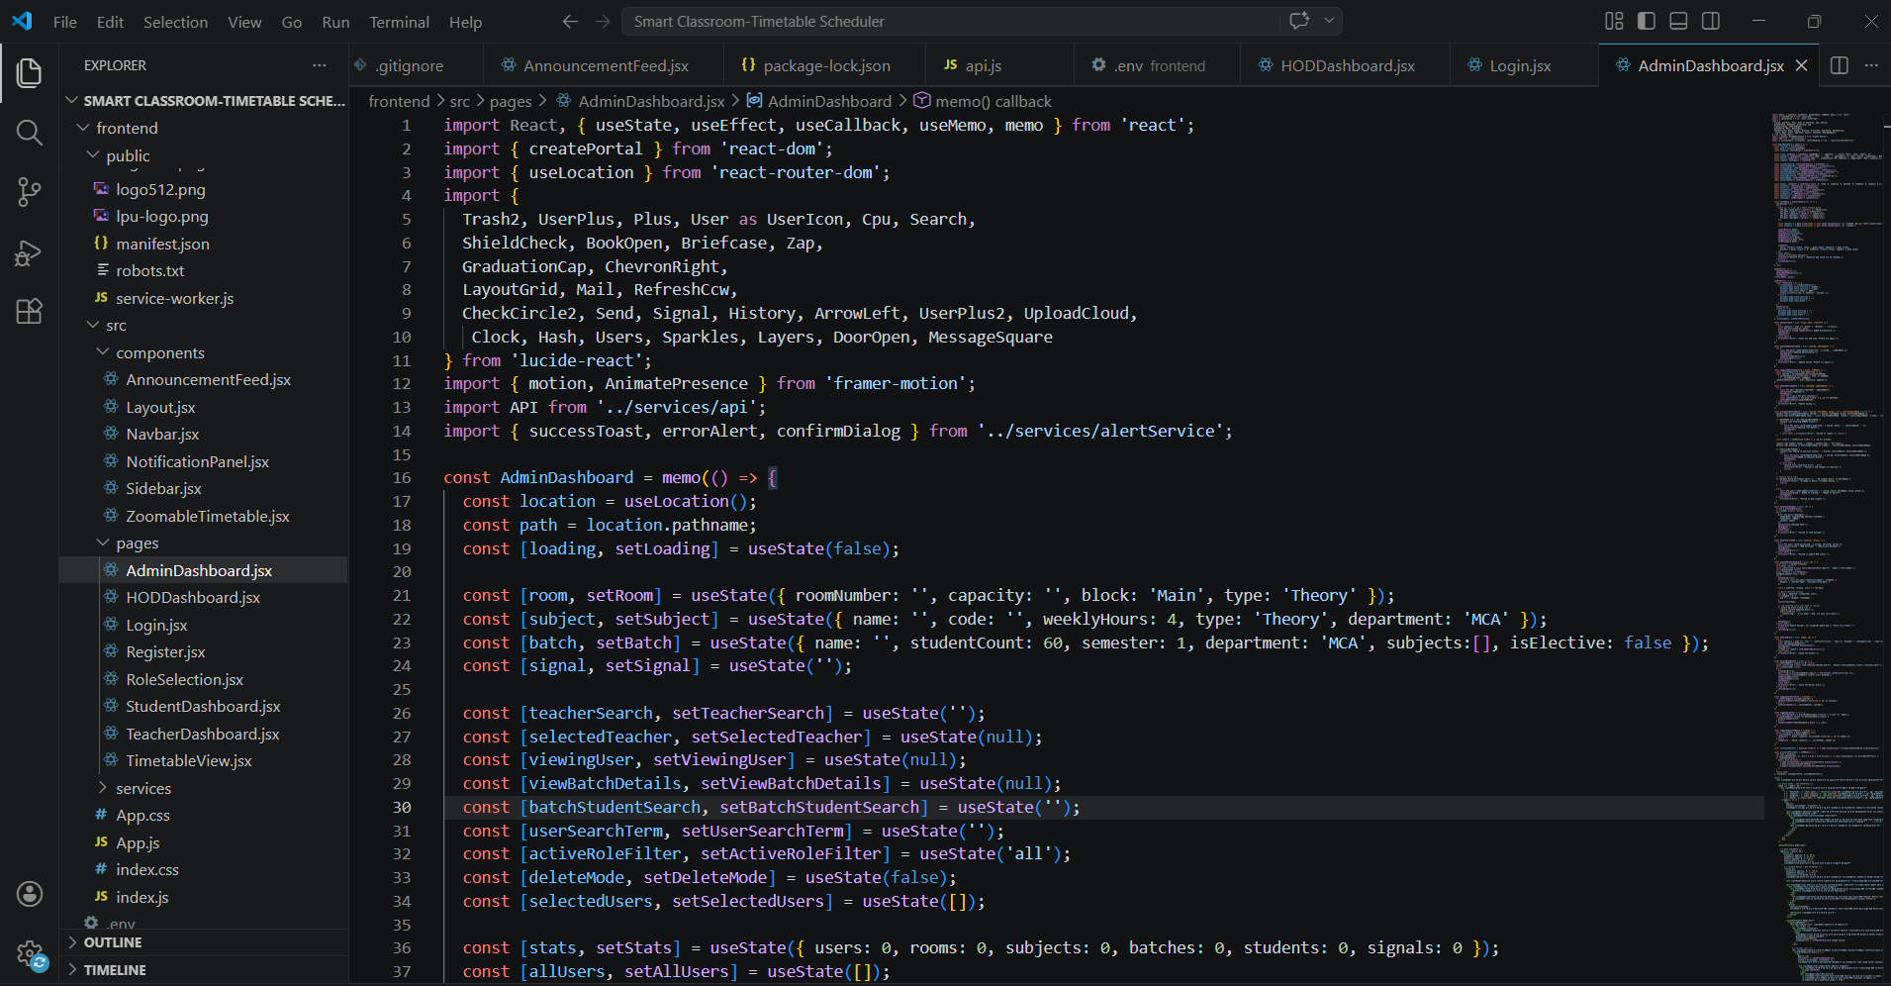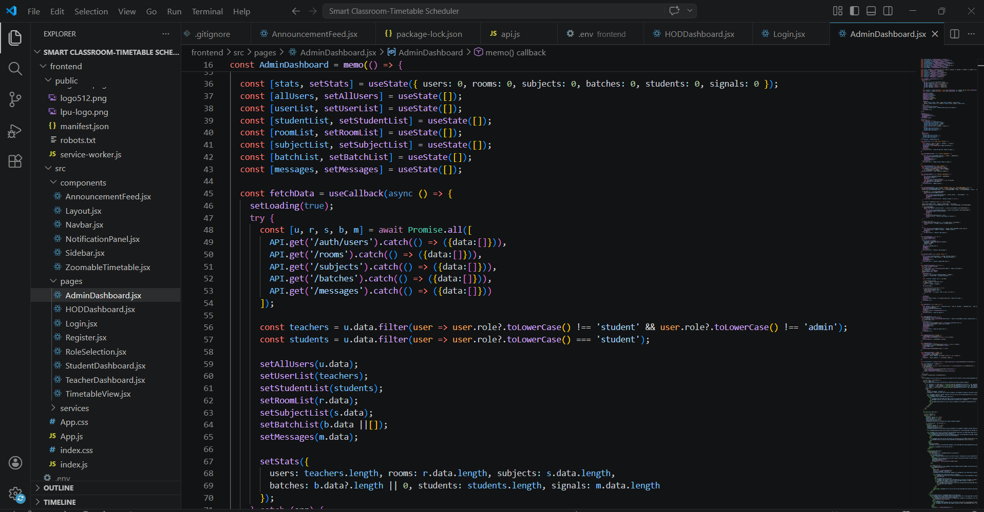

HOD Dashboard:
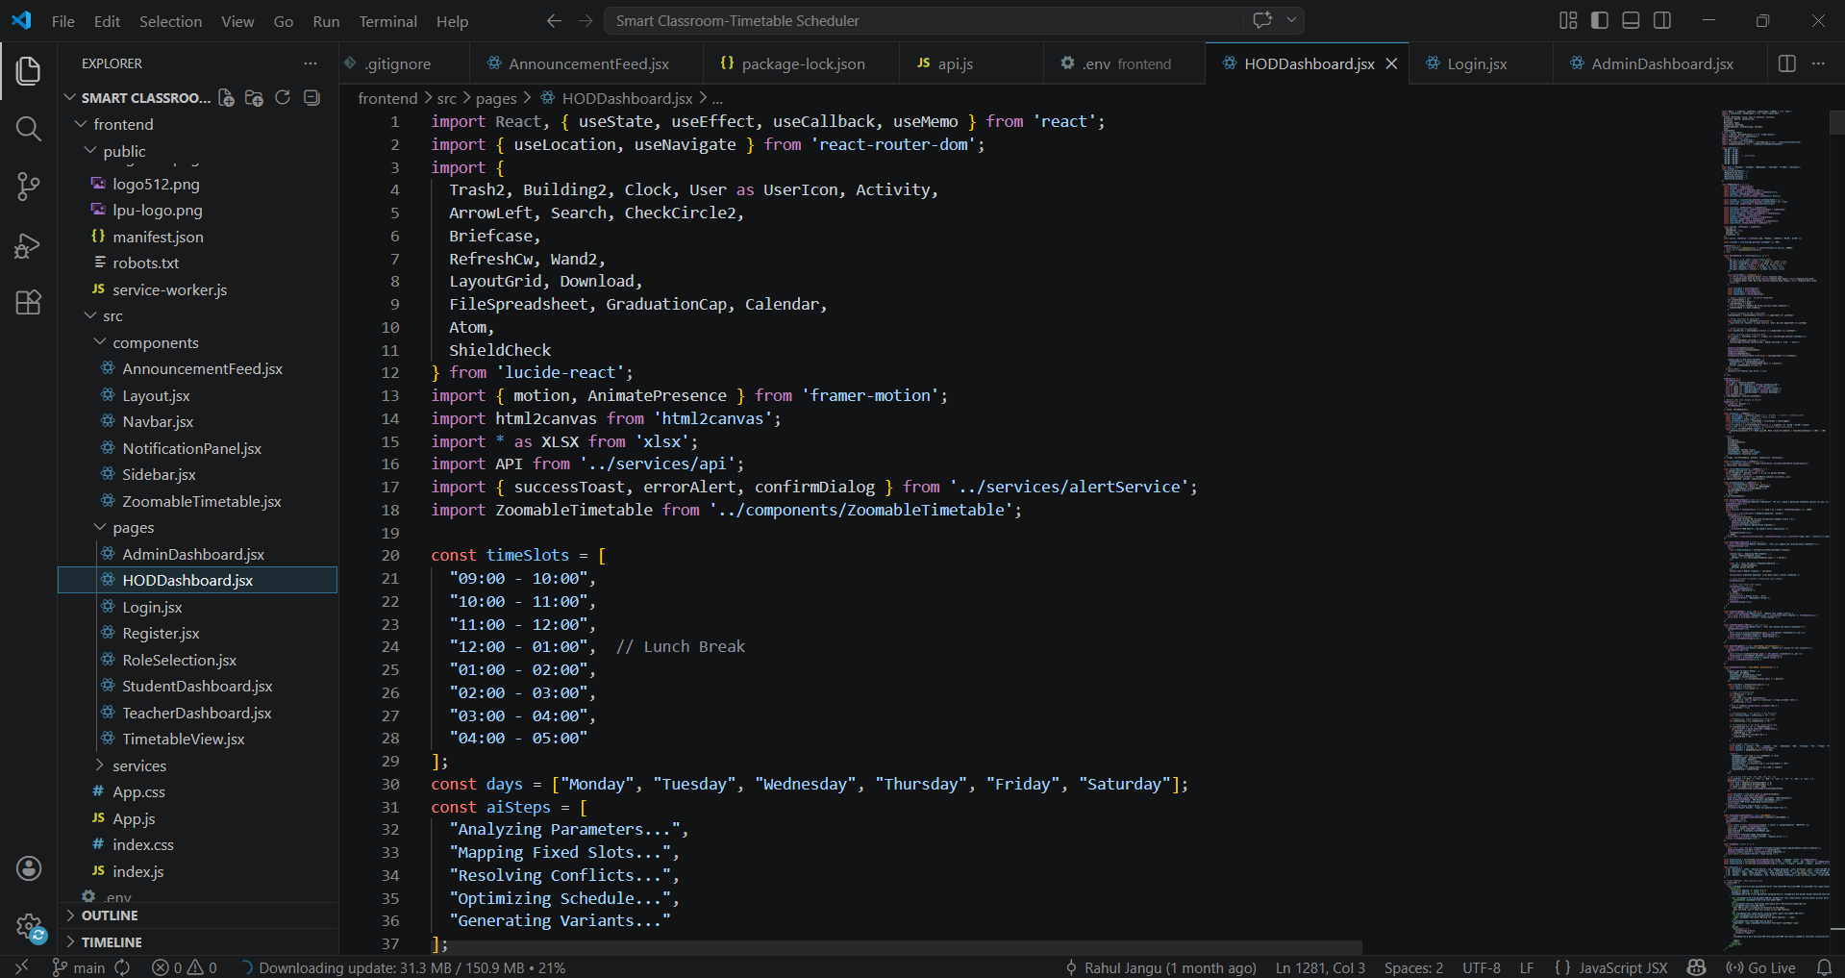
Teacher Dashbaord:
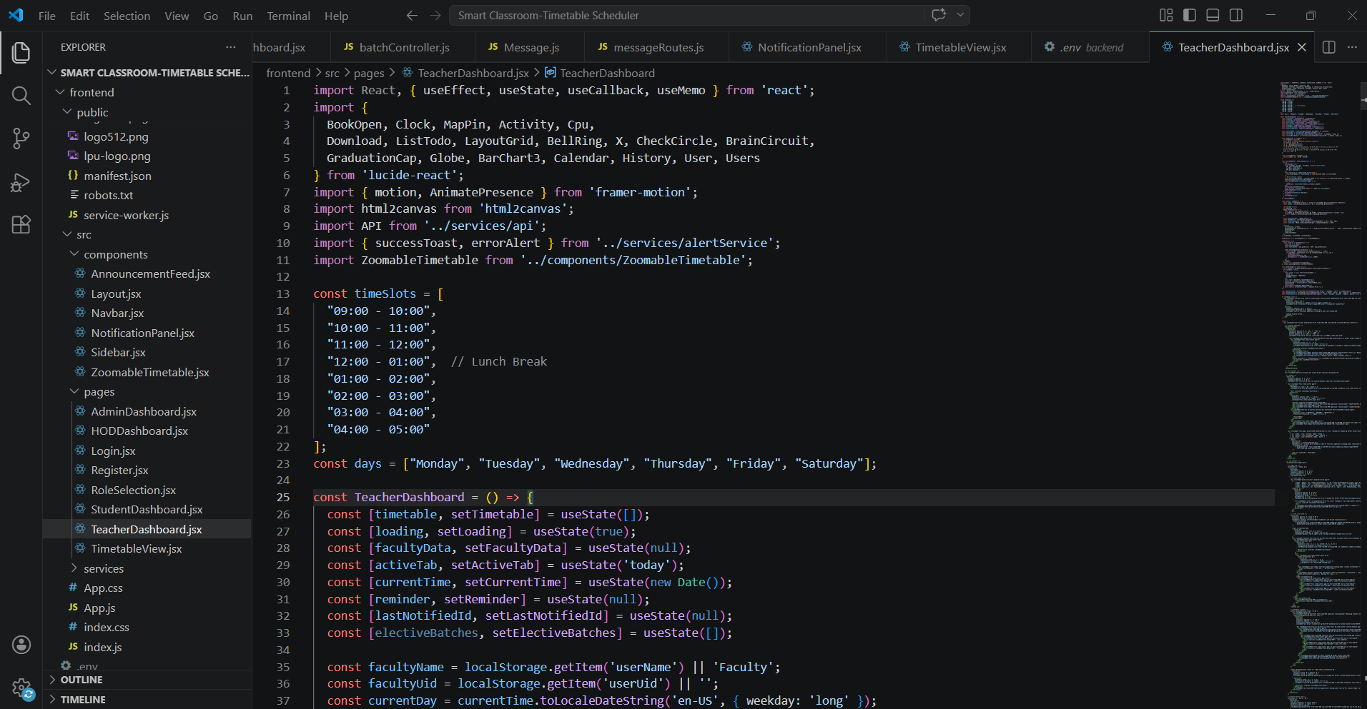

Student Dashbaord:
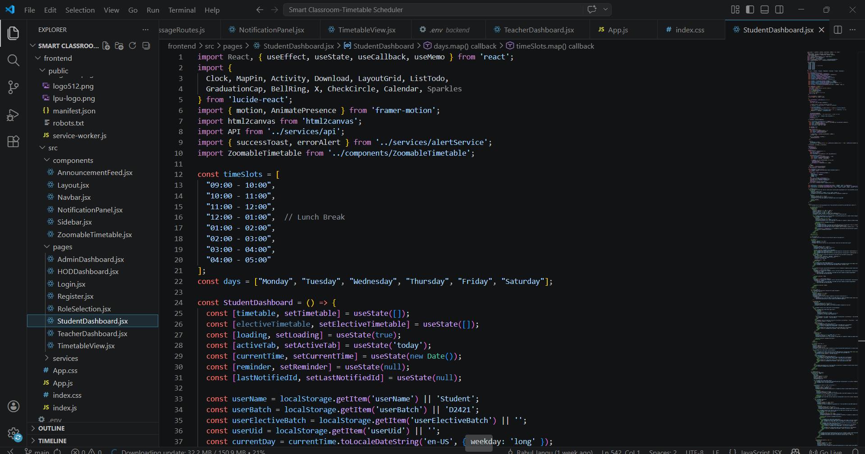

Login and Register:
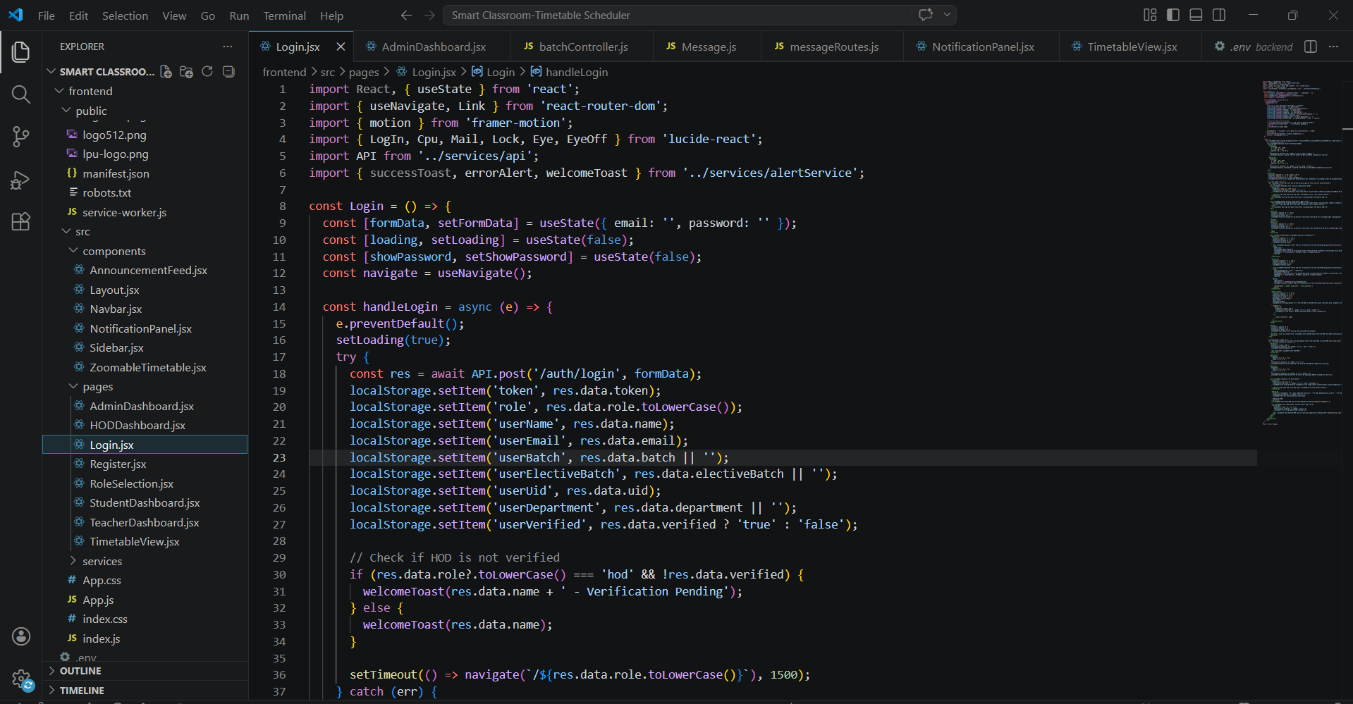
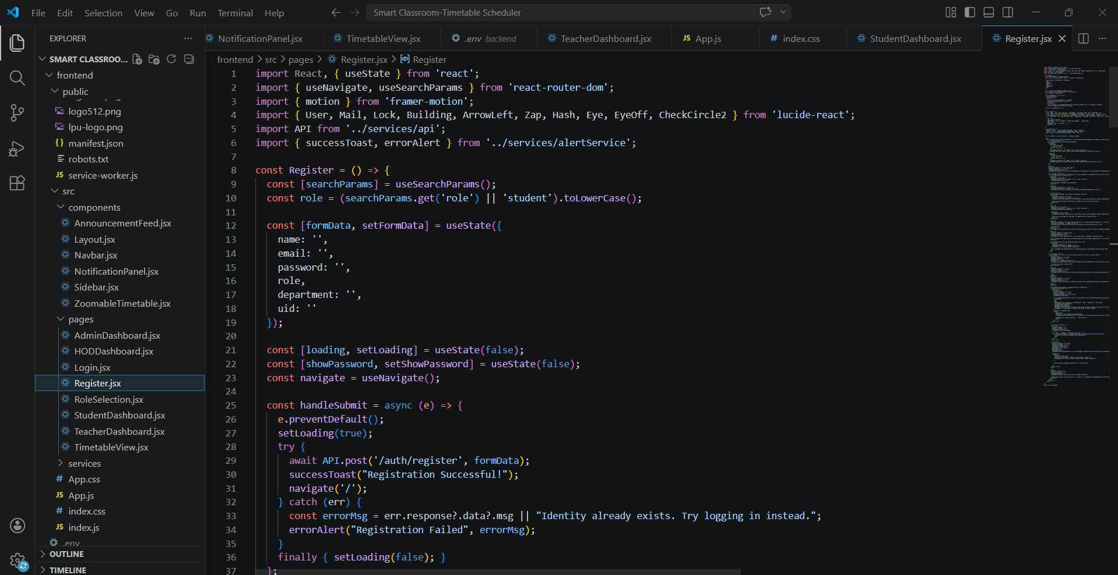

aiShedulerController.js;
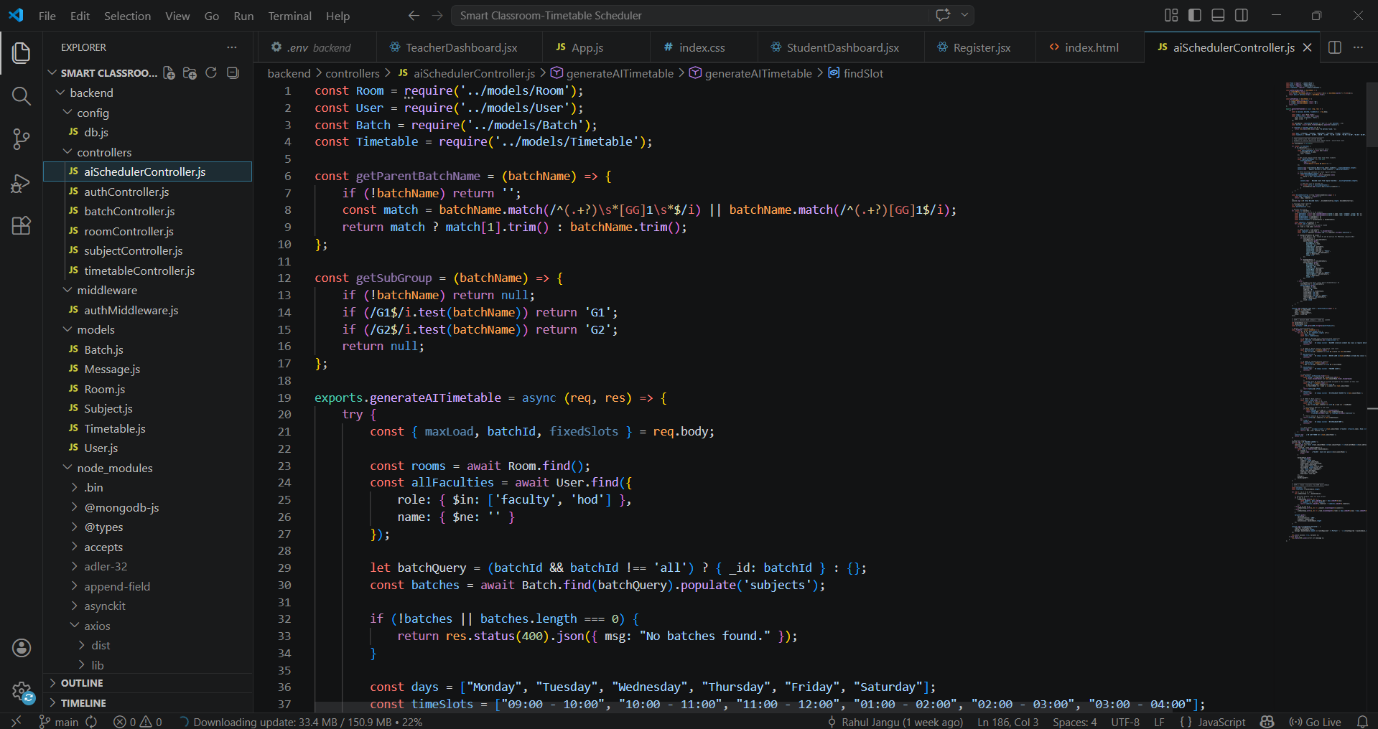
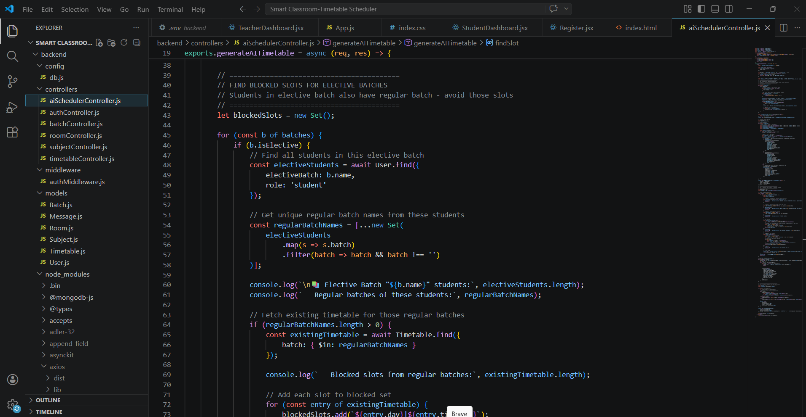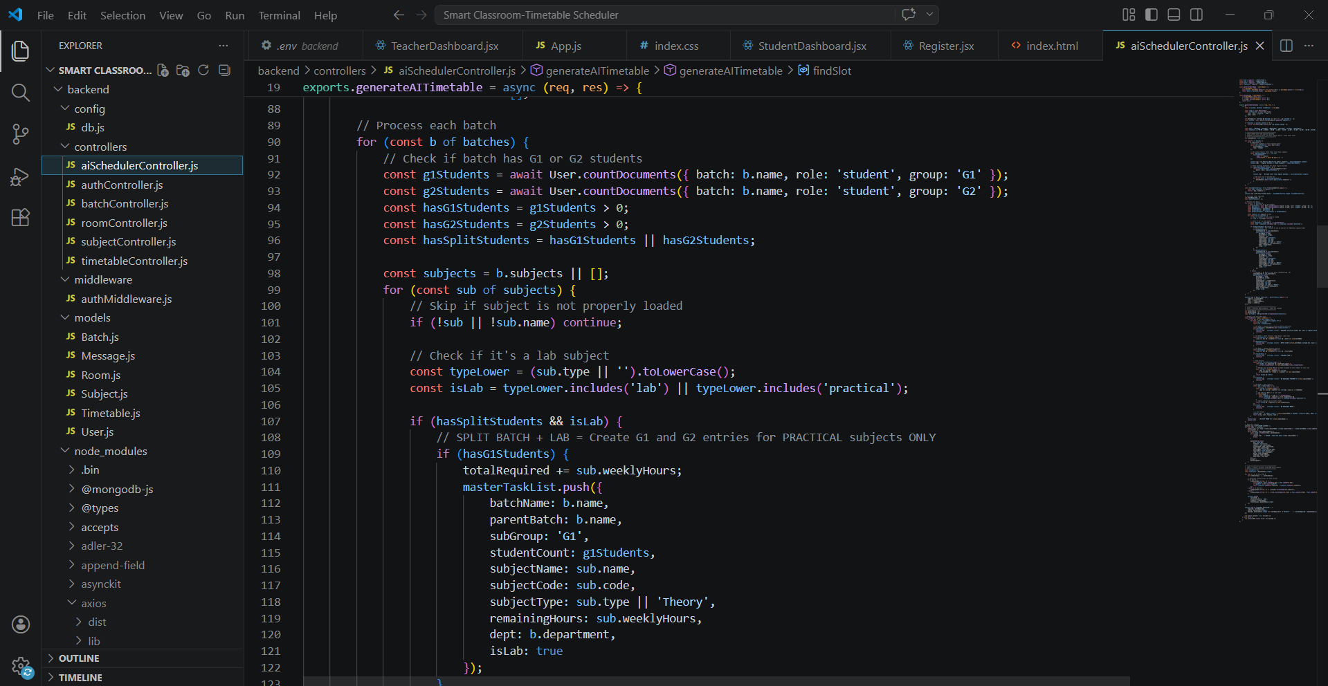

authController.js:
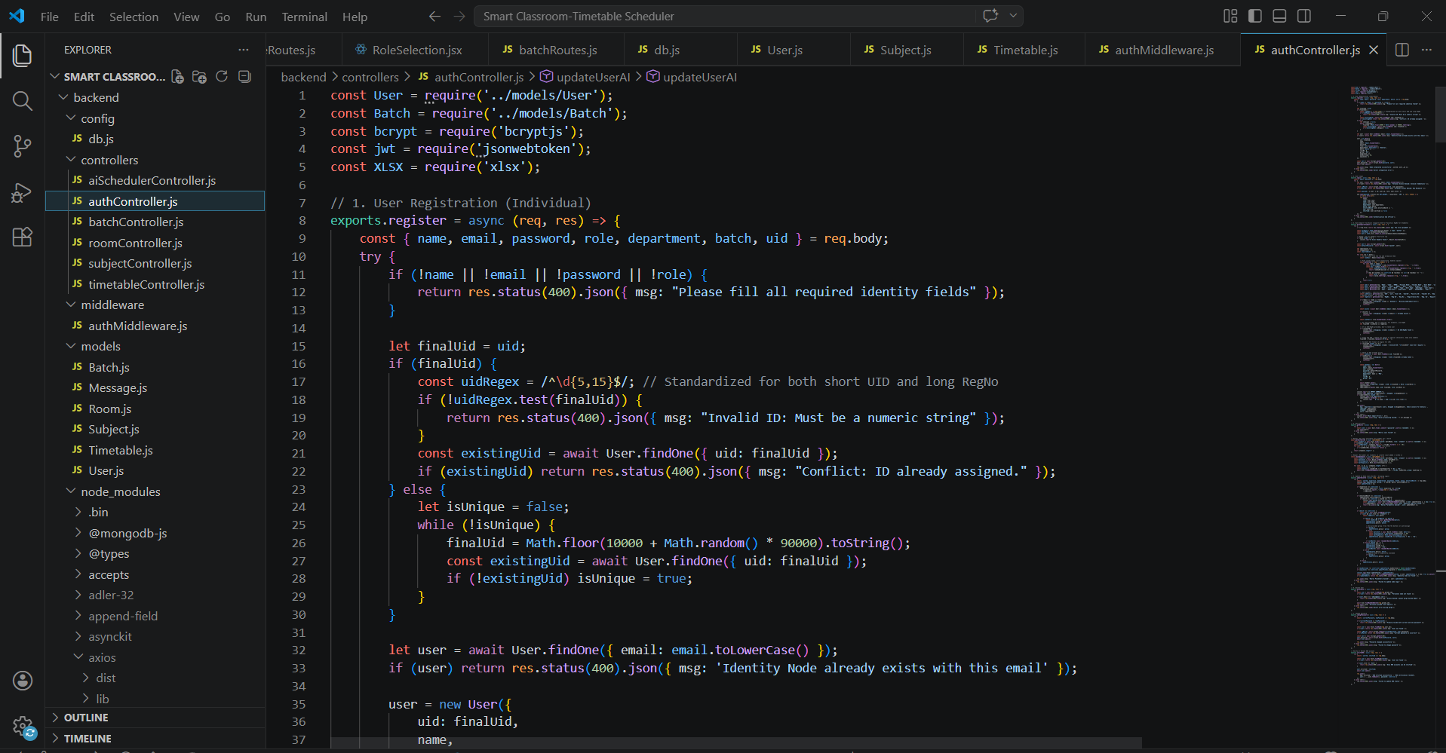

batchController.js:
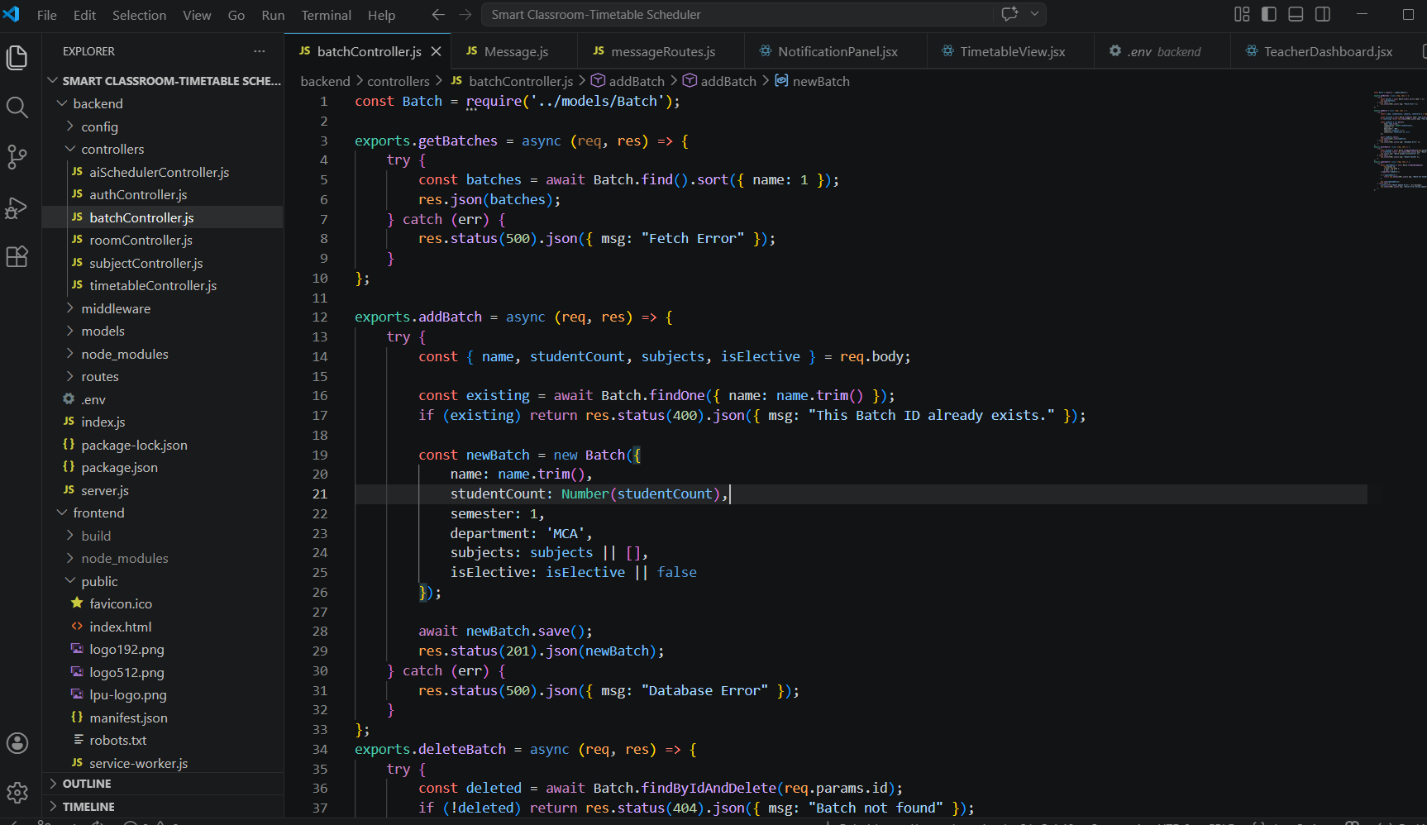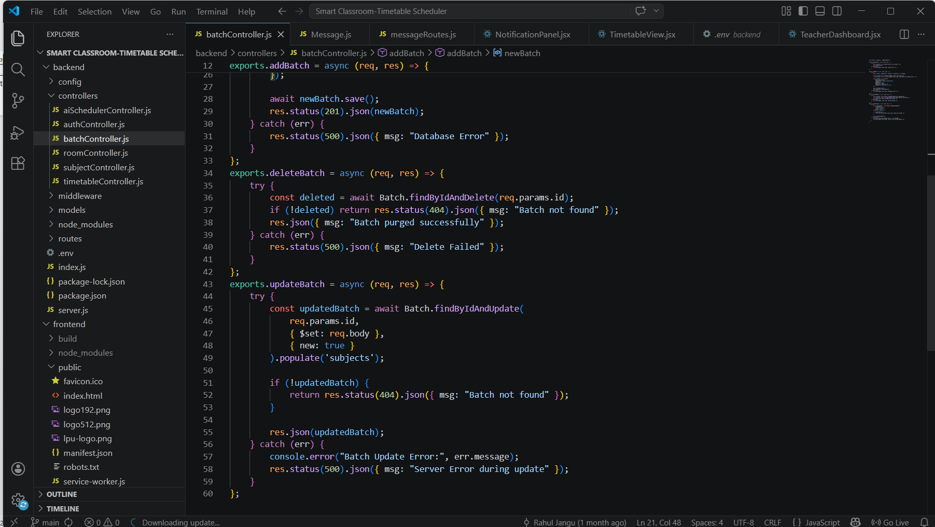

roomController.js:
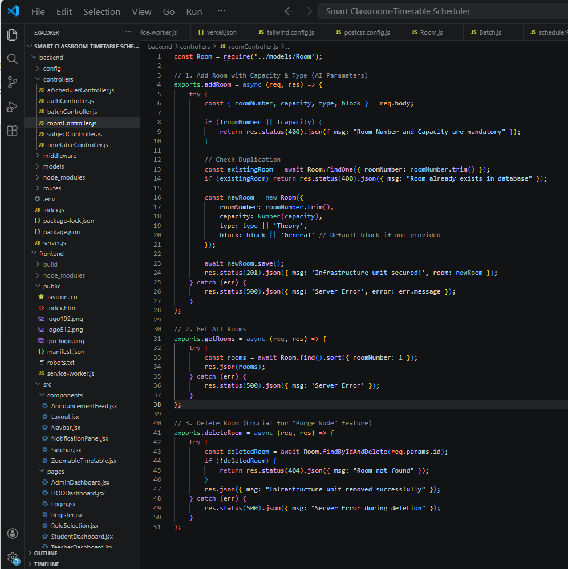

timeTableController.js:
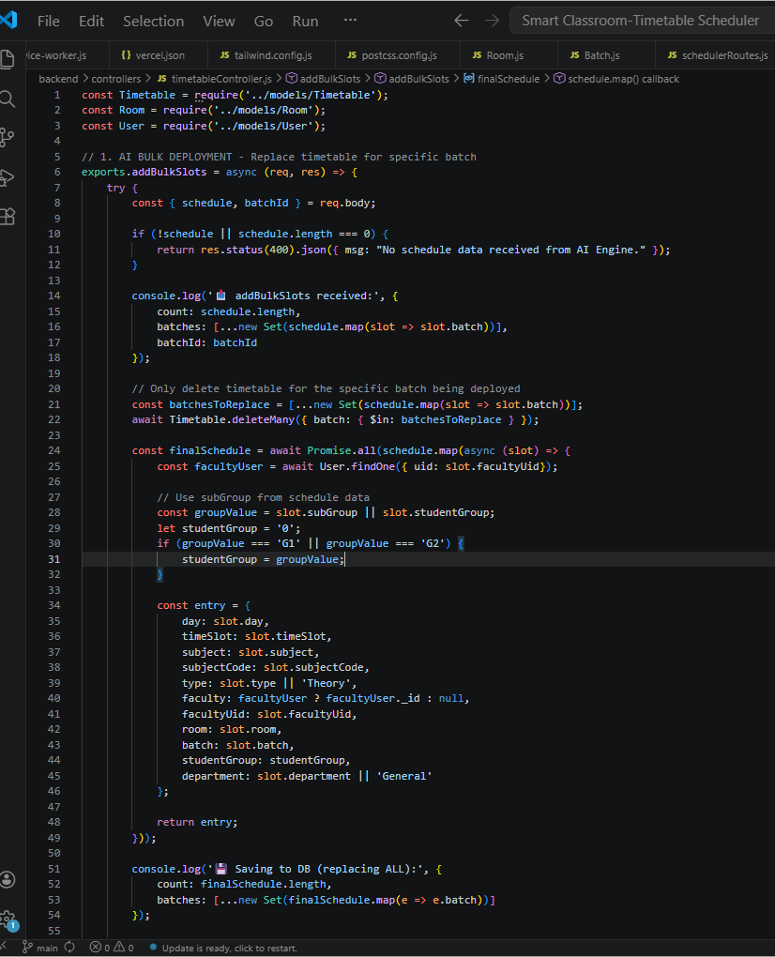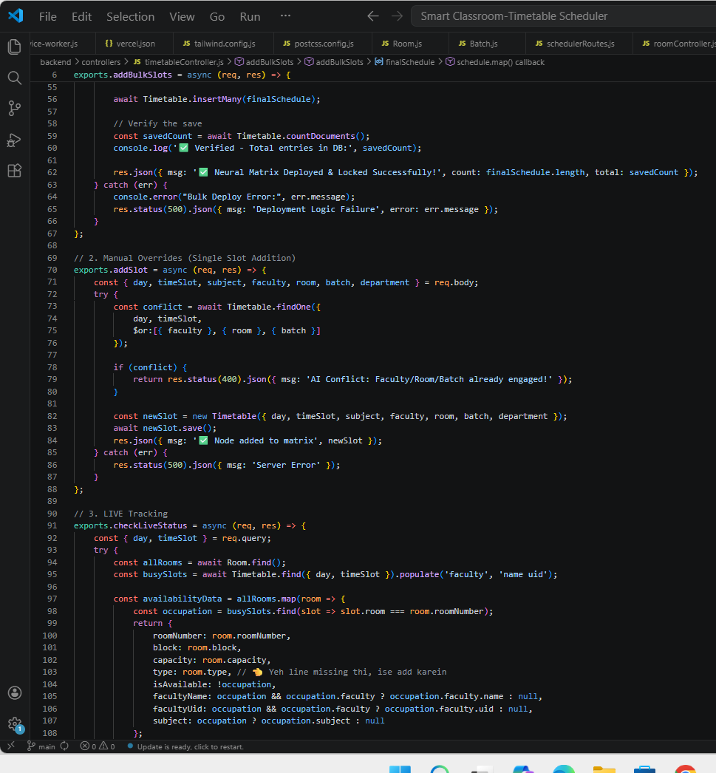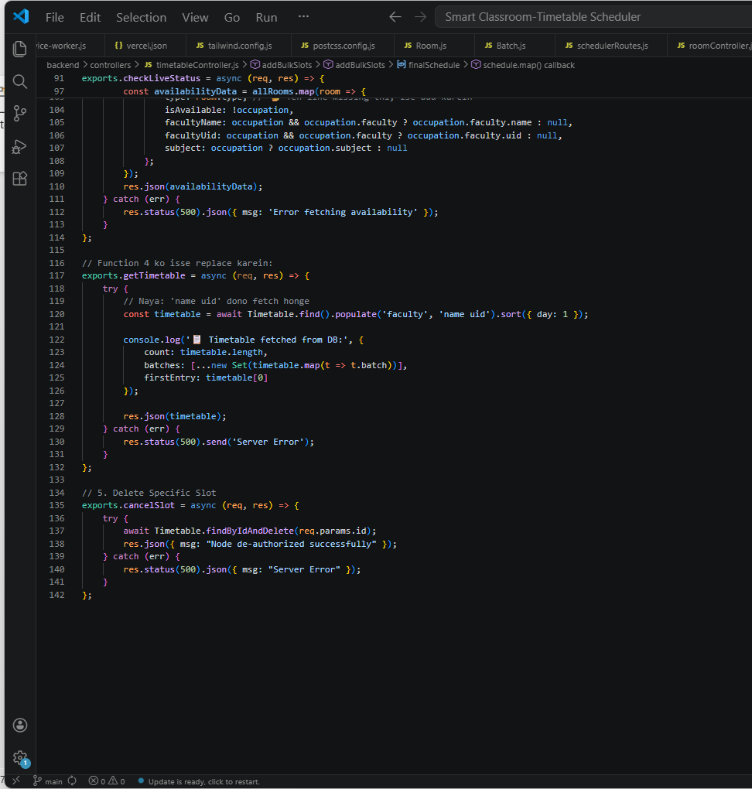

3.8 List of figures
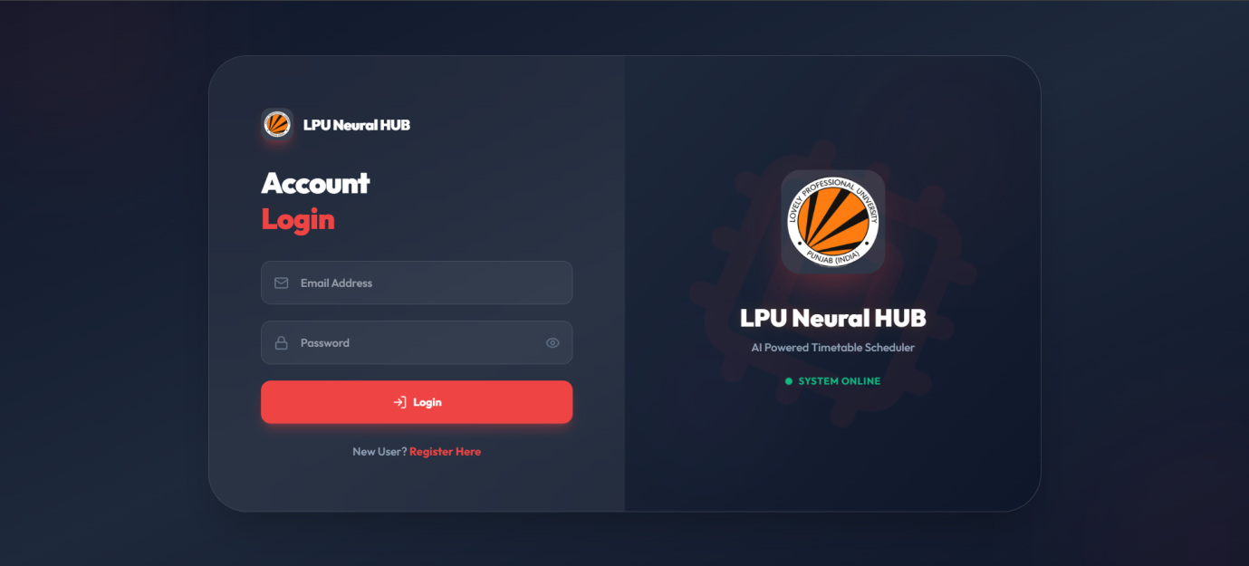

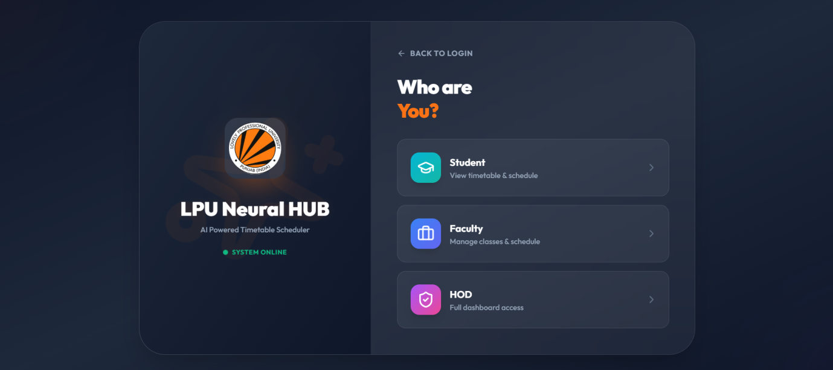

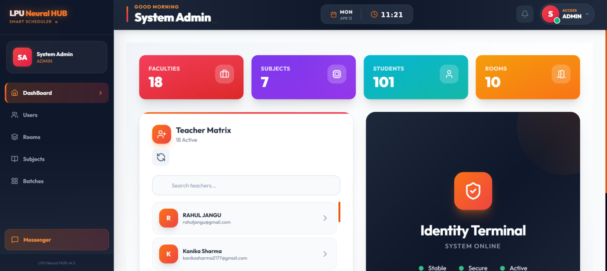

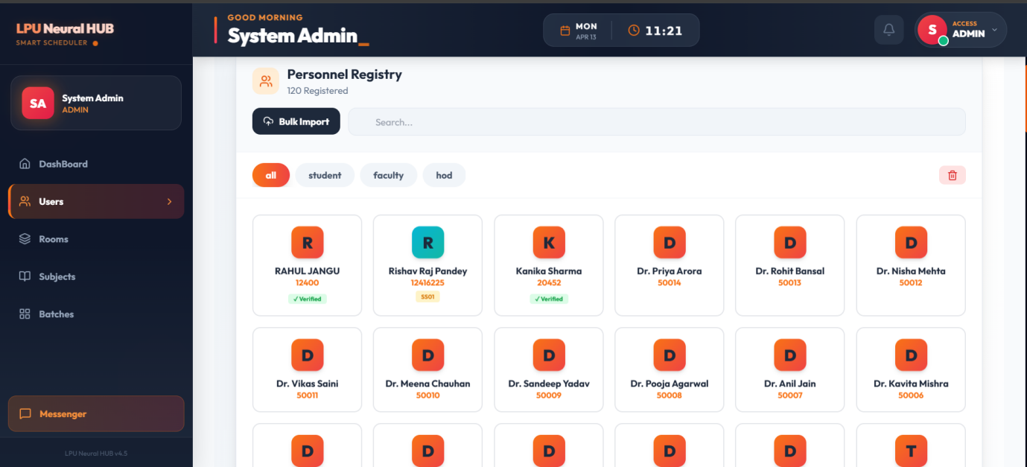
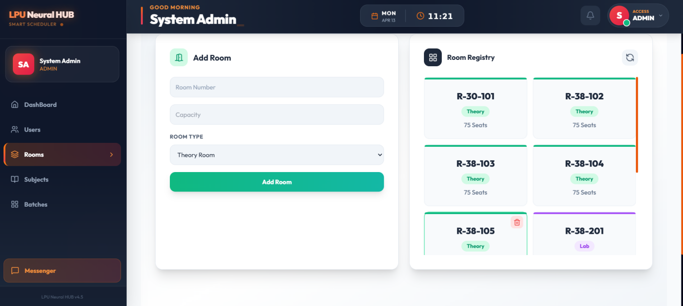
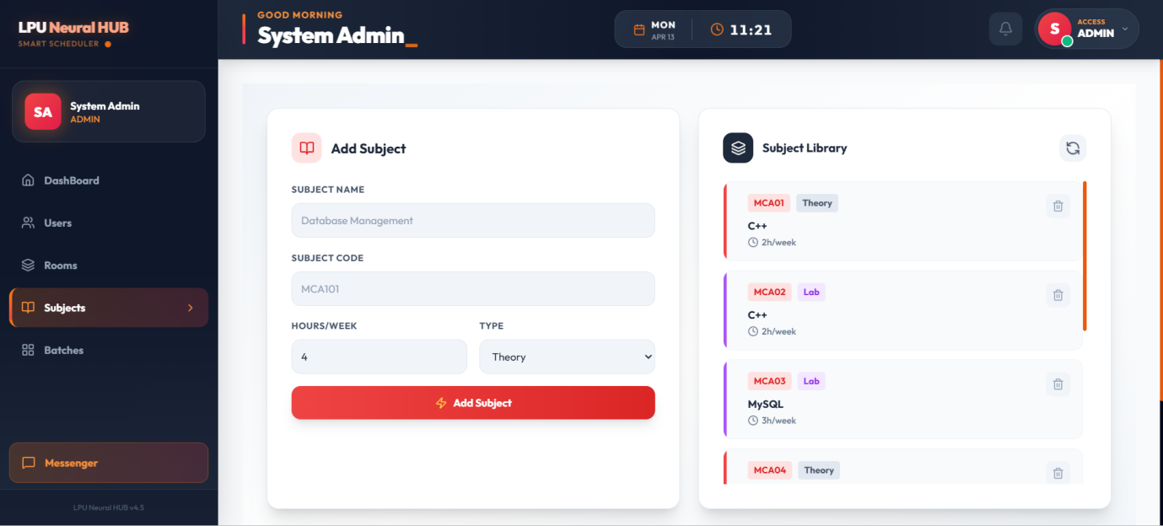
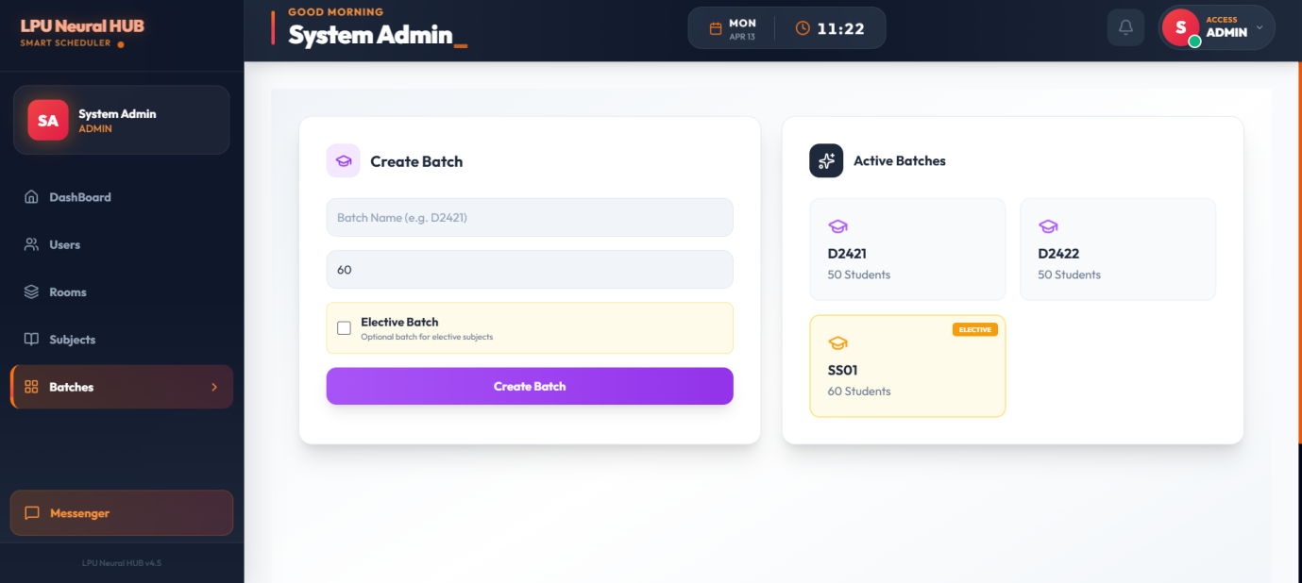
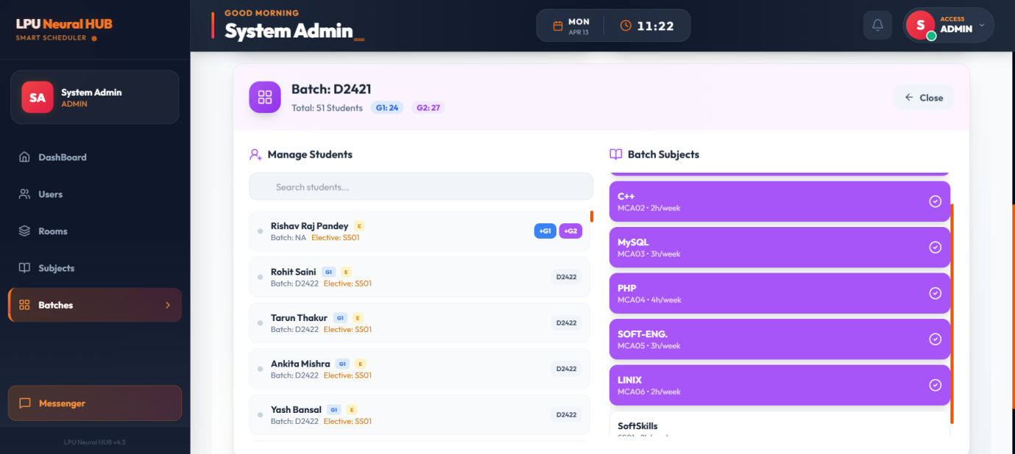

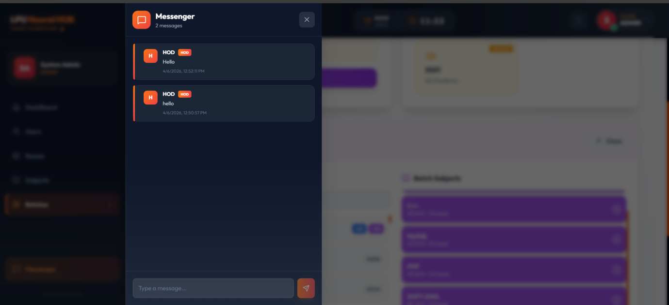

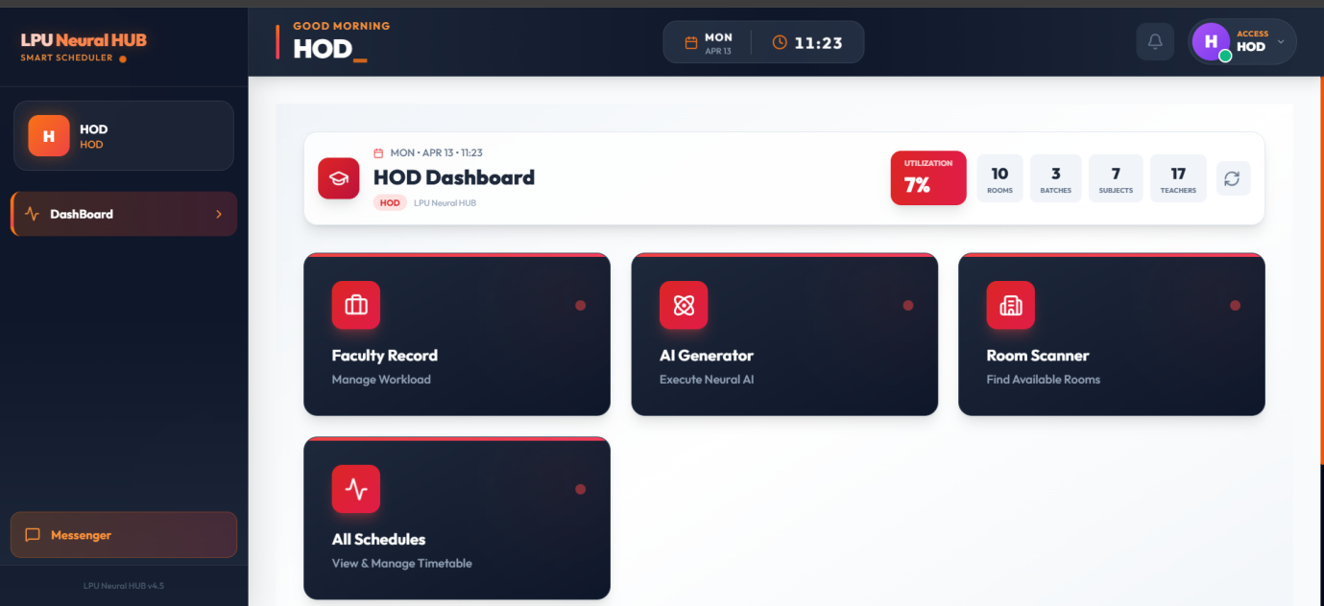

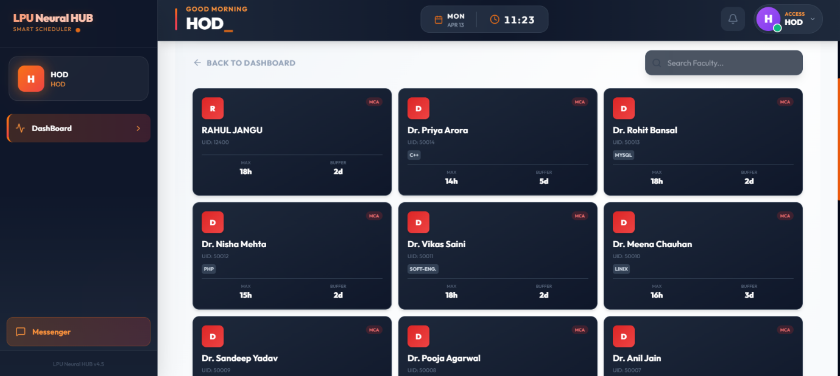

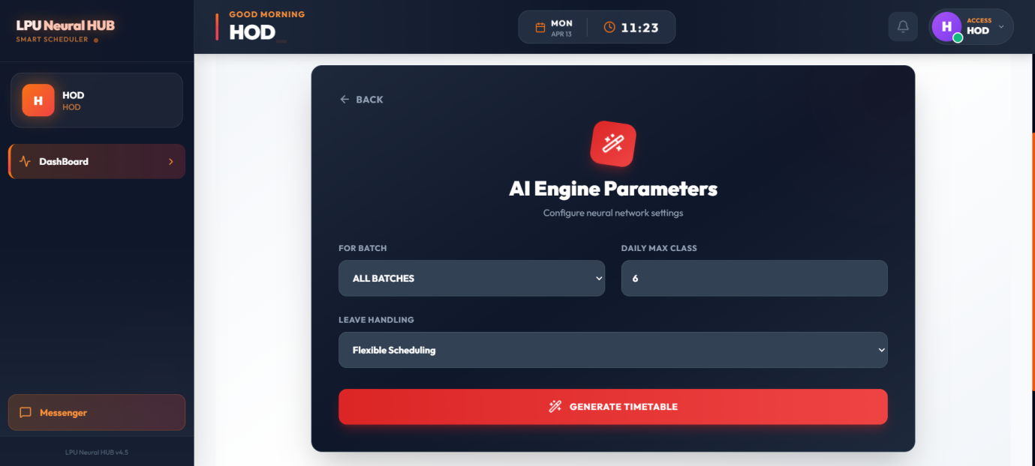

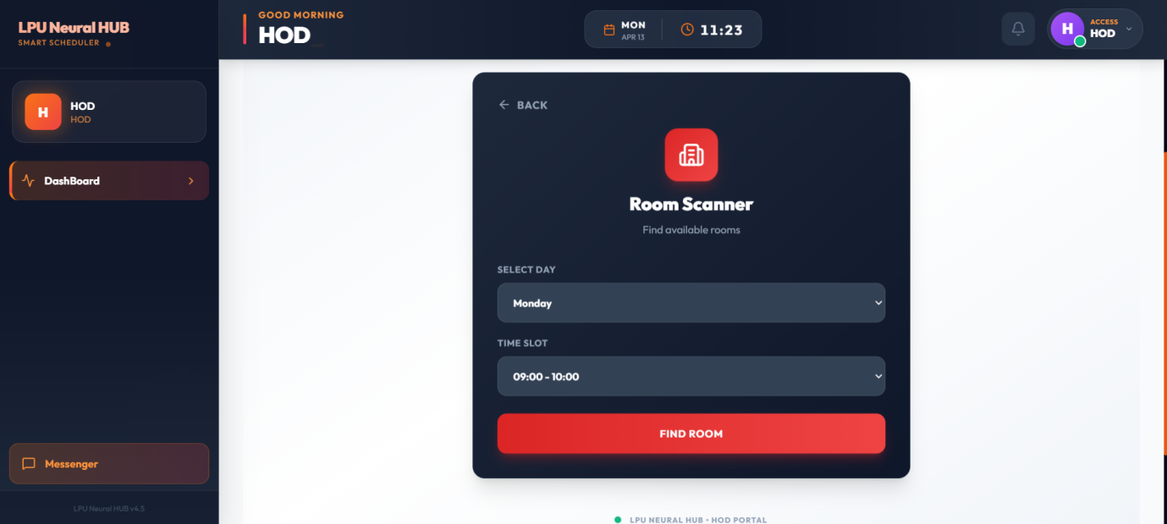

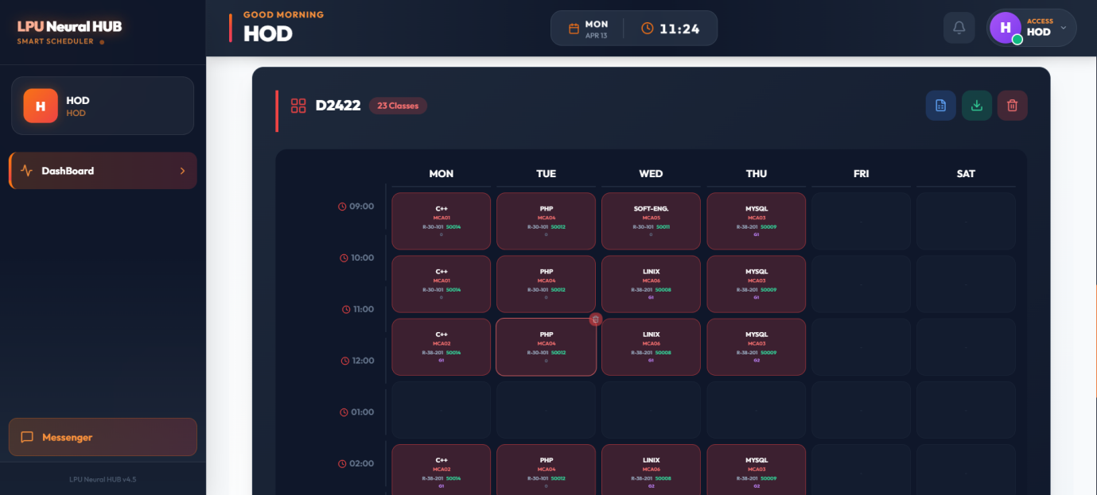

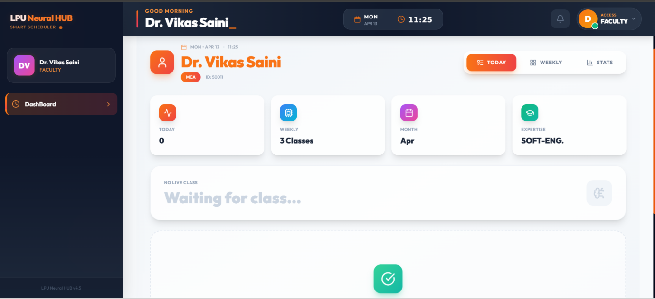

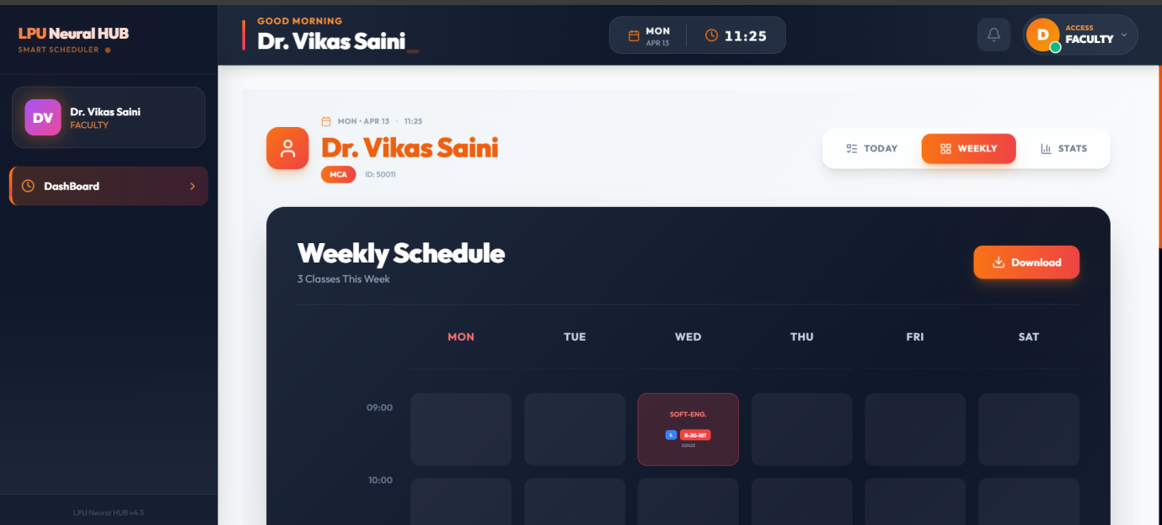
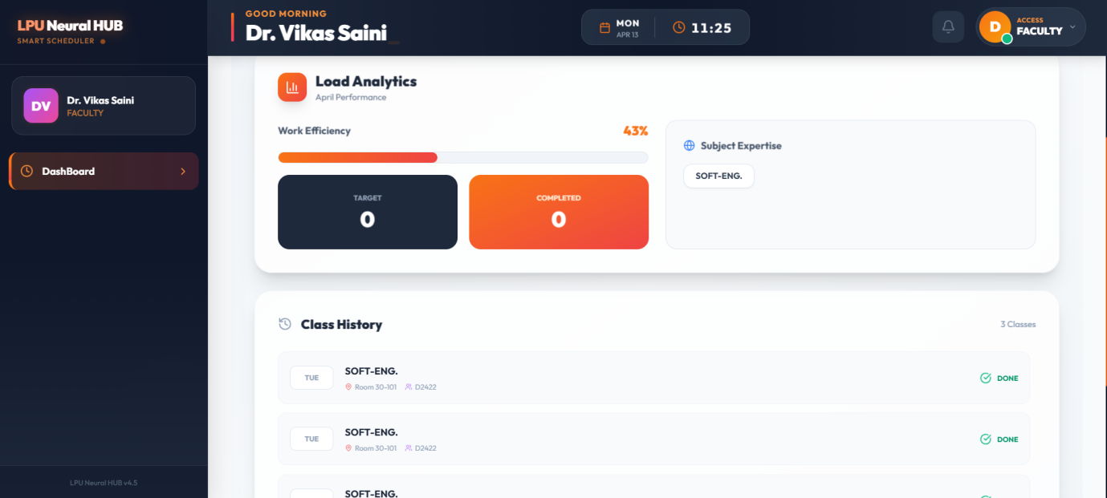

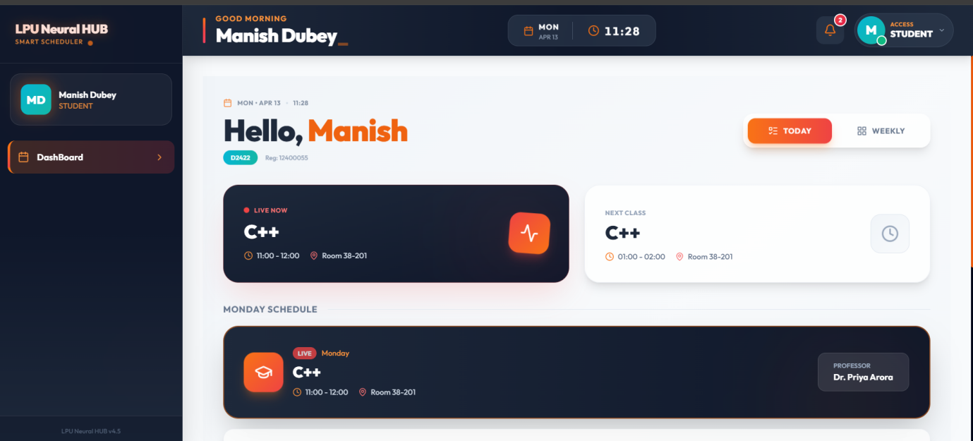

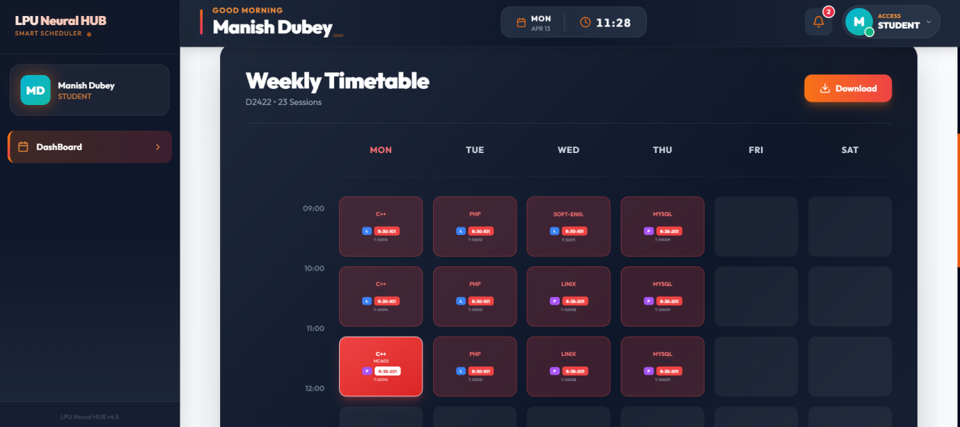

CHAPTER 4
Results and Discussions
Academic operational failure and resource clashing create a major challenge in Indian higher education, especially affecting large-scale institutions where nearly 16% of total instructional hours were lost due to scheduling inefficiencies during 2023-24. The friction in academic progression persisted to be a major problem in the recent academic year due to manual scheduling errors, classroom underutilization, and faculty workload imbalances as well as individual student disengagement. Institutions generally face delays in finalizing academic roadmaps because of various logistical issues and unmapped infrastructure conditions.
These operational setbacks affect the institutional reputation and simultaneously slow down the academic growth of student batches. In response to the need for a more modernized approach to institutional management using digital transformation, the Indian government adopted the National Education Policy (NEP) 2020. Resource availability and schedule planning without conflict are some of the topmost priorities of this policy.. Digital technology, specifically the LPU Neural Hub, holds an important position in supporting this initiative.
The results of our neural framework illustrate that sophisticated data analysis permit educational institutions to identify scheduling bottlenecks and students who need immediate intervention. The Early Warning System (EWS) effectively detects academic setbacks by monitoring the 75% attendance and 7.5 CGPA thresholds. Quick administrative support, together with teacher direction, becomes achievable when intervention occurs before these learning obstacles lead to a dropout. The discussion focuses on how this intelligent equipment regulates the academic lifecycle; the system generates three optimized timetable variants based on current performance levels and resource availability, thus keeping institutional interest active.
The implementation of the Active Matrix (Timetable) and Room Topology Scanners ensures that students and faculty enjoy a synchronized educational environment. Collaborative tools such as the Community Hub and Web Learning Platform provide access to digital libraries and virtual tutoring, that are crucial for addressing disinterest. Furthermore, the framework addresses the "Socioeconomic Friction" by automating merit-based financial aid. Through the PDF Generation Engine, eligible students can secure educational support without facing the manual barriers that often create obstacles to their achievement.
Our system also resolves the complexity of batch management by implementing Auto-Increment Roll Numbers and G1/G2 Group Splitting. This guarantees that learners who might otherwise discontinue their studies due to large class volumes or lack of individual attention receive a way to examine their progress in a more managed environment. By maintaining a secure identity uplink and real-time data refresh, the LPU Neural Hub ensures that even if students encounter academic or financial challenges, they continue to be linked with their education through an intelligent, supportive digital ecosystem.
CHAPTER 5
Conclusion and Future Scope
5.1 CONCLUSION
The operational inefficiency in academic scheduling remains a crucial problem which affects numerous learning institutions across specialized universities. Institutional friction and resource clashes often happen rapidly after the commencement of an academic cycle. Suboptimal scheduling during a student's studies creates negative impacts on their career prospects as well as their academic self-assurance and overall life quality. Defects in the institutional community arise from elevated administrative overhead together with reduced pools of engaged learners. Many students leave education because of dissatisfaction with their academic results, although financial instability and scheduling fatigue due to manual errors represent additional common factors leading students to drop out.
The exit category includes individuals with no interest in their education due to rigid scheduling, along with those suffering from a lack of academic support. The LPU Neural Hub provides an intelligent framework to solve this problem which exists in the modern digital society. With tools such as the Neural Scheduling Engine, we can identify students and resources in need of intervention through a combination of tracking systems, 4-tier dashboards, and early warning systems (EWS) which provide real-time indicators about student conditions. The opportunity arises to intervene through the "Red Line Protocol" before a situation moves past the recovery point. The equipment provides continuous updates to HODs and faculty while offering students both automated reminders and merit-based financial support. The software platform provides a bridge between administrative efficiency and psychological care. This project has successfully constructed a software solution which combines intelligence with user-friendliness for lowering attrition rates and optimizing classroom allocation.
5.2 FUTURE SCOPE
The system currently operates to decrease operational friction within the university environment; however, its future outlook is vast. Upcoming developments will focus on integrating Adaptive Learning Modules that adjust curriculum difficulty based on real-time quiz results. We aim to include Voice-Assisted AI for learners with reading challenges and expanded modules for inter-university sports and cultural coordination. These enhancements will enable teachers to obtain even better knowledge about their students' requirements.
Future iterations will also explore Blockchain-based Identity Verification to secure student registries and automated Virtual Mentoring sessions triggered by the EWS. These devices will help administrators better understand resource requirements, which supports student learning within the academic environment. The lengthy outlook shows that by creating an "Intelligent Matrix" where resources are optimized and students achieve better results, we will create an enhanced future for both the institution and its stakeholders.

APPENDIX
Technologies Used in the MERN Stack Project
The MERN stack includes a combination of powerful and reliable software solutions based on the JavaScript language that can be used to develop highly efficient full-stack applications. The architecture of the LPU Neural Hub includes four major systems – namely, MongoDB, Express.js, React.js, and Node.js, along with contemporary front-end frameworks such as Tailwind CSS and Framer Motion.
- HTML5 (HyperText Markup Language)
HTML5 forms the basis of the app, which provides semantic structure to the web portals. In this case study, HTML is employed for structuring the “Active Matrix” (timetable), nodes of the user profile, and registry for administration purposes. This helps in ensuring that information is properly arranged for the users and the neural algorithms.
2. CSS3 (Cascading Style Sheets)
It is the CSS3 that takes charge of all the visual styling and layouting of the structure built using HTML. Here, CSS will be in charge of ensuring that the entire Cyber Terminal look is created, from the dark dashboard designs to the glassmorphism effects.
3. JavaScript (ES6+)
JavaScript provides the core interactivity and dynamic behavior of the system. It is utilized as a cross-platform language on both the client-side (browser) and server-side (Node.js). Within the LPU Neural Hub, JavaScript handles real-time data calculations, form validations, and the execution of the conflict-resolution logic.
4. React.js (Frontend Engine)
React.js is a sophisticated library of JavaScript used for creating complicated user interfaces by Meta. The SPA application ensures that loading of the four dashboards such as Admin, HOD, Faculty, and Student will be done with no need for page refreshes. With the modular approach, React allows the creation of components for different parts of the user interface including Room cards and Identity Modals using the Virtual DOM.
5. Tailwind CSS (Styling Framework)
Tailwind CSS is an example of a CSS framework that incorporates the utility first concept whereby all the UI design is generated instantly using the HTML code. It does not require any customization of the CSS code sheets at all since everything will be entirely responsive. In the present project, Tailwind will be helpful in ensuring that the dashboards and Red Line features are mobile friendly.
6. Node.js (Server Runtime)
The runtime environment for the execution of JavaScript code on the server-side is Node.js. It helps in creating the server-side structure of the Hub application and dealing with complex business logic along with handling multiple requests that come simultaneously from all four user interfaces.
7. Express.js (Backend Framework)
Express is a lightweight framework used to build applications in Node.js that simplifies the process of creating server-side routes and building REST APIs. For this particular application, Express is responsible for handling communications between the front-end terminals and the database, thereby ensuring smooth data transfers for the Early Warning System (EWS) and Financial Aid PDF generator.
8. MongoDB Atlas (Cloud Database)
MongoDB is a NoSQL, document-oriented database used to store institutional data in flexible, JSON-like formats. In the LPU Neural Hub, MongoDB serves as the centralized repository for the "Personnel Registry," storing longitudinal data such as attendance history, CGPA records, and room topologies in a highly scalable and efficient manner.
9. Supporting Libraries (Advanced Integration)
- Framer Motion: Utilized for high-end UI animations, providing a "springy" and smooth experience for the Identity Modals.
- XLSX & Multer: Integrated for the "Bulk Excel Import" feature, allowing the Admin to synchronize hundreds of student records instantly.
- Html2Canvas: Enables students and faculty to export the "Active Matrix" as a high-resolution image for offline use.

References
- Smart India Hackathon (SIH). (2023). Problem Statement ID: 25028 - "Smart Classroom & Timetable Scheduler." Submitted by the Department of Higher and Technical Education, Government of Jharkhand. Organized by Ministry of Education’s Innovation Cell, Government of India. [Primary source of the research problem].
- Ministry of Education, Govt. of India. (2020). National Education Policy (NEP) 2020. (Focus on Multidisciplinary Curricula and Flexible Learning modules cited in the framework).
- Government of Jharkhand. (2023). Department of Higher and Technical Education: Administrative Guidelines for Infrastructure Optimization in Technical Institutions.
- Babaei, H., Karimpour, J., & Hadidi, A. (2015). A survey of automated university timetabling algorithms. Journal of King Saud University - Computer and Information Sciences, 27(4), 430-441. (Basis for conflict resolution engine).
- Qu, R., Burke, E. K., & McCollum, B. (2009). A survey of search methodologies and automated system development for university self-adaptive timetabling. IEEE Transactions on Systems, Man, and Cybernetics. (Supports the multi-variant generation logic).
- Gupta, S., & Kumar, R. (2022). Intelligent Resource Allocation using Cloud-based MERN Stack Frameworks in Academic Management. International Journal of Advanced Computer Science and Applications.

